agro ethno ecology

Foodcrop-Livestock-Forestry Production
in the Humid Lowland Tropics

Land  Class | Fertility &  Topography | Six Diversified & Integrated Units for  Foodcrop-Livestock-Forestry Production
Class A | Better Agricultural Land | 1. ANNUAL STAPLE FOODCROPS  in Large Rotated Fields Page 16
Class B | Average Agricultural Land | 2. BIENNIAL HORTICULTURAL FOODCROPS  with Small Rotated Plots in Dooryard Gardens 26  3. COMMERCIAL PRODUCTION OF FREE-RANGE CHICKENS  with Night Shelters in Dooryard Gardens 28
Class C | Inferior Agricultural Land | 4. PERENNIAL FOODCROPS & FRUIT TREES  in Large Permanent Orchards 37  5. COMMERCIAL PRODUCTION OF Tethered & Penned PIGS  in Large Permanent Orchards 40
Class D | Permanent Forestry  Land | 6. COMMERCIAL PRODUCTION OF TIMBER & COCOA TREES  in Large Enriched Forests 43

Mesoamerican Edition

agro ethno ecology Our Life Support System

Asociación Ak' Tenamit (New Community) is

an indigenous rural development organization

that promotes long-term solutions to poverty in

the rainforests of eastern Guatemala through

education, health, income generation, and cultural programs

run by and for the Q'eqchi' Maya.

Ak' Tenamit‘s Board of Directors is 100% indigenous

(50% women/50% men/average age 23) and

100% representative of the villages Ak' Tenamit serves.

Asociación Ak' Tenamit has received awards from the

UN Economic and Social Council (UNESCO) and the

World Innovation Summit for Education (WISE) for over

20 years of innovative programs in universal rural education.

Mesoamerican Edition

2015
Translated and published by Tropical Production Systems (www.humidtropics.com)
based on the Edición Ak' Tenamit (2012) originally published in Spanish by
Instituto Ak' Tenamit (www.aktenamit.org) and Tropical Production Systems.
All reproductions, modifications, and translations are authorized.
section A: Introduction
Improving the foodcrop-livestock-forestry production of traditional rural families with limited financial resources in the Humid Lowland Tropics is essential for food security and an improved rural development that is economically more equitable, sociologically more just, and ecologically more sustainable.
The Humid Lowland Tropics can be defined as tropical areas with more than 1500 mm/yr rainfall and less than 900 m elevation. Approximately 77% of all the world’s tropical lands are lowlands with elevations below 900 m, and approximately 53% of all tropical lands are in the Humid Tropics with rainfall exceeding 1500 mm/yr* (see Figures 3-4). However, approximately 75% of land area in the Humid Lowland Tropics is less-fertile hill-land.** Therefore, the universal use of both profitable and sustainable foodcrop-livestock-forestry production practices has critical importance for food security and improved rural development.
Figure 3. Geographic Areas of the American, African, and Australasian
Humid Lowland Tropics.*** 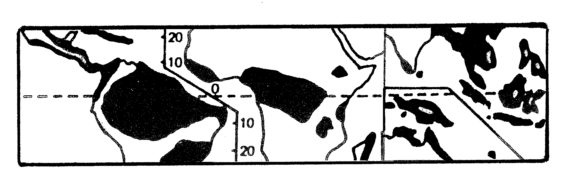
* Buol, S.; Sanchez, P. (1978) Rainy Tropical Climates: Physical Potential, Present and Improved Farming
Systems. International Congress of Soil Science. 2:292-312, Edmonton, Canada.
** Plucknett, D. (1976) Hill Land Agriculture in the Humid Tropics. In: Hill Lands, West Virginia University Books,
Morgantown, West Virginia.
*** Williams, C.; Joseph, K. (1976) Climate, Soil and Crop Production in the Humid Tropics. Oxford University Press,
Kuala Lumpur, Malaysia.
To have food security and improved rural development on less-fertile hill-lands in the Humid Lowland Tropics, it is not only necessary to develop newer more sustainable and profitable management practices for foodcrop-livestock-forestry production, but it is also necessary to compile the existing traditional and modern management practices, as well as put them in agro/climatic/edaphic/ topographic and ethno/socio/economic contexts, to then initiate the local validation and mass transfer of the highest priority practices (see Figure 7).
This technical manual focuses on the development, compilation, validation, and transfer of sustainable and profitable foodcrop-livestock-forestry management practices that favor rural families with limited financial resources on less-fertile hill-lands in the Humid Lowland Tropics; giving priority to practices that intensify and diversify traditional foodcrop-livestock-forestry production with more integrated and efficient use of available family labor, land, plant, and animal resources. (Renewable Resources)
This technical manual presents in SECTIONS A & B the Introduction and Technical Background (pages 1-15), whereas SECTION C presents detailed information on Six Diversified and Integrated Units for Foodcrop-Livestock-Forestry Production utilizing more than 50 plant and animal species (pages 16-48). Also included throughout this technical manual are more than 100 references, footnotes, and illustrations.
This technical manual is the product of more than 10 years of field trials at the Instituto Ak’ Tenamit (New Community High School) as part of its 6 year Rural Development Studies Program.* The Instituto Ak’ Tenamit benefits Q'eqchi' Maya communities in the Humid Lowland Tropics of northeastern Guatemala.** The Q'eqchi' Maya population is estimated to be over 1.5 million in northeastern Guatemala and southern Belize and is currently estimated to be the world’s largest Tropical Rainforest Ethnic Group (see Figures 4-5). Field trials at the Instituto Ak' Tenamit have been based on the following Agro-Ethno-Ecological Parameters and Goals.
Parameters: Goals:
- Less-Fertile Hill-Lands*** - Productivity & Profitability
- Field Rotation & Dispersion**** - Sustainable & Sustaining
- Diversified & Integrated Production***** - Biodiversity & Biointensity
- Traditional Rural Societies - Equal Opportunity
- Limited Financial Resources - Low Financial Inputs
______________
*Ak' Tenamit field trials (2002-2011) were a continuation of INIAP-UFL-ILV (1972-1982) and
MAG-USAID (1982-1991) field trials in the Ecuadorian Humid Lowland Tropics.
**Wilson, R. (1995) MAYA RESURGENCE IN GUATEMALA: Q’eqchi' Experiences. Univ. Oklahoma Press.
***Sánchez, H. (2009) Planificación del Uso de la Tierra de la Asociación Ak' Tenamit, Aldea Barra de Lámpara,
Municipio de Livingston, Departamento de Izabal, Guatemala. Programa de Ejercicio Profesional Supervisado,
Facultad de Agronomía, Universidad de San Carlos de Guatemala.
****Demarest, A. (2004) Ancient Maya: The Rise and Fall of a Rainforest Civilization. Cambridge Univ. Press.
*****Fedick, S. (1996) The Managed Mosaic: Ancient Maya Agriculture and Resource Use. Univ. Utah Press.

Figure 4. Geographic Area of the Mesoamerican Humid Lowland Tropics.*

*Sources: Ministerio de Agricultura Ganadería y Alimentación (2001) Precipitación Promedio Anual. Guatemala.
Universidad Rafael Landivar (2004) Perfil Ambiental de Guatemala.
New Comparative World Atlas (2002) www.hammondmap.com, USA.
The World (2010) www.seegermap.com, USA.
Caribbean Atlas (1997) Macmillan Education Ltd., London.
Atlas Geográfico de Honduras (2005) Ediciones Ramsés, Tegucigalpa.
Figure 5. Major Ethnic Languages in the Mesoamerican
Humid Lowland Tropics.*

Twenty-four major ethnic languages are spoken in the Humid Lowland
Tropics of Mexico, Belize, Guatemala, Honduras, Nicaragua, Costa Rica, and Panama. The major ethnic languages in Mesoamerica are listed below.

MEXICO HONDURAS
- Lacandon Maya - Cho'rti' Maya**
- Chol Maya - Pech
- Chontal Maya - Sumo**
- Tzeltal Maya - Ramo**
- Tojolabal Maya - Garίfuna**
- Miskito**
BELIZE NICARAGUA
- Q'eqchi' Maya** - Sumo**
- Mopán Maya** - Ramo**
- Garίfuna** - Miskito**
- Creole - Garίfuna**

GUATEMALA COSTA RICA
- Q'eqchi' Maya** - Bribrί**
- Mopán Maya** - Guaymί**
- Poqomchi' Maya
- Achί Maya PANAMA
- Ixil Maya - Ngőbe (Guaymί)**
- Itza' Maya - Buglé
- Cho'rti' Maya** - Bribrί**
- Garίfuna** - Naso - Kuna - Emberá
- Wouhaan

*National Geographic (2002) Mapa Pueblos Indígenas y Ecosistemas Naturales en Centro América y Sur de México.
Washington D.C.
**Ethnic language groups that are trans-national.

section B: Technical Background

Importance of Agricultural Sustainability

The agricultural sustainability of less-fertile hill-lands in the Humid Lowland Tropics depends on: (a) Maintaining Soil Nutrients and Organic Matter (botanical/microbial/macrobial), (b) Stabilizing Soil Physical Structure and Controlling Soil Erosion, and (c) Reducing Weed Propagation and Pest Multiplication. These 6 critical factors can tolerate moderate short-term cyclic variations; they cannot, however, be allowed to decline continuously.*
Land degradation contributes to food insecurity, limits efforts to alleviate poverty, and constrains human development in much of the Humid Lowland Tropics.** There is urgent need to intensify and sustain the productivity, as well as improve the incomes of traditional rural families with limited financial resources in the Humid Lowland Tropics; and thereby reverse the retrogressive process of land degradation, declining crop production, and deepening human depravation.*** Land degradation is both a consequence of hunger and poverty, as well as a basic cause of hunger and poverty!
On less-fertile hill-lands in the Humid Lowland Tropics, many unprofitable and unsustainable attempts have been made trying to develop continuous cultivation systems for the production of annual staple food crops utilizing modern Agro-Industrial/Capital-Intensive management practices (see Figure 6). However, even on more-fertile/non-tropical lands around the world, most modern Agro-Industrial/Capital Intensive production units for annual staple foodcrops (e.g. corn and soy beans in USA) only have a 4-month/year cultivation cycle (growing season), with only a 33 1/3% foodcrop cultivation intensity. By comparison, on less-fertile hill-lands in the Humid Lowland Tropics, Biodiverse/Biointensive production units with a 12-18 month cultivation cycle for the production of annual staple foodcrops, followed by a 12-18 month rotation cycle for fertilizer legumes, have a 50% foodcrop cultivation intensity (see Figure 11).

____________________
*Nye, P.; Greenland, D. (1960) The Soil under Shifting Cultivation. Tech. Commun. 51, Comm. Bur. Soils,
Harpenden, Great Britain and University of Ghana, West Africa.
**Bishop, J. (1978) The Development of a Sustained Yield Tropical Agro-Ecosystem in the Upper Amazon.
Agro-Ecosystems, 4:459-461.
***Bishop, J. (1984) The Dynamics of the Shifting Cultivation, Rural Poor, Cattle Complex on Marginal Lands
in the Humid Tropics. In: Social, Economic, and Institutional Aspects of Agro-Forestry, NRTS-23/UNUP-502,
United Nations University, Tokyo, Japan.

Figure 6. Six Causes of Land Degradation with an

Analysis of Two Management Alternatives.

Causes of Analysis of Two Management Alternatives: Land Degradation: Biodiverse/Biointensive* Agro-Industrial**

(Corrective Efficacy) (Corrective Efficacy)
1. Biological Degradation of Soil High Low
(Soil lacks organic matter)
2. Physical Degradation of Soil High Average
(Soil is compacted)
3. Chemical Degradation of Soil High Average
(Soil lacks nutritional elements)
4. Soil Erosion High Average
5. Pest Multiplication High Average
6. Weed Propagation High High

Cost-Benefit Analysis:
1. Cost Levels Low High
2. Benefit Levels High Average

________________________________________________________________

*Biodiverse/Biointensive Management Practices Include:
- Multiple-cropping of traditional crops, local varieties, and low financial inputs;
- Crop and field rotations;
- Mixed production of low-cost fertilizer legumes;
- Slash-and-mulch organic cover on inter-row contour strips;
- Minimum tillage in contour rows;
- Open local markets with small-scale transportation.

**Agro-Industrial/Capital-Intensive Management Practices Include:
- Monocropping with few high-tech varieties and high financial inputs;
- High-cost chemical fertilizers, herbicides, and pesticides;
- Heavy mechanical tillage;
- Controlled national and international markets with large-scale transportation.

Importance of Agricultural Profitability
Profitable Agricultural Practices are of two types: (1) those with Economic Comparative Advantages for larger Agro-Industrial/ Capital-Intensive production units, and (2) those with Economic Comparative Advantages for smaller Biodiverse/Biointensive production units.
1) Profitable Agricultural Practices with Economic Comparative Advantages for larger Agro-Industrial/Capital-Intensive production units usually are highly specialized, horizontally integrated, and have high financial inputs. Agro-Industrial/Capital-Intensive agricultural practices include: (a) monocropping of high-tech/high-demand hybrid varieties, (b) expensive chemical fertilizers, herbicides, and pesticides, (c) heavy mechanical tillage, and (d) controlled regional, national, and international markets with large-scale private transport. Such Agro-Industrial/ Capital-Intensive management practices are more profitable and have Economic Comparative Advantages for larger production units. (Comparative Advantages)
Agro-Industrial/Capital-Intensive management practices favor larger production units because they become more-and-more cost-effective as the size of production units increase. As a result traditional rural families have more-and-more difficulty competing. In fact, larger Agro-Industrial/Capital-Intensive production units work more effectively by the truckload, purchasing inputs by the truckload and marketing outputs by the truckload. Therefore, in many rural areas we now find more-and-more land dominated by larger-and-larger, highly specialized, horizontally integrated, Agro-Industrial/Capital-Intensive production units, often at urban-based regional, national, and international corporate levels. Examples include banana, sugar cane, rubber, oil palm, and cattle ranches. (Economies of Scale & Cost Effectiveness)
2) Profitable Agricultural Practices with Economic Comparative Advantages for smaller Biodiverse/Biointensive production units usually are highly diversified, vertically integrated, and have low financial inputs. Biodiverse/Biointensive management practices include: (a) integrated and diversified foodcrop-livestock-forestry production with multiple-cropping of traditional crops and local varieties which have low financial input requirements, (b) crop and field rotations, (c) mixed production of low-cost fertilizer legumes, and (d) open local markets with small-scale public transport. Such traditional Biodiverse/Biointensive management practices are more Cost Effective and have Economic Comparative Advantages for smaller production units, because they make more efficient use of available family labor, land, plant, and animal resources; and thus have higher productivity and profitability levels for traditional rural families with limited financial resources in the Humid Lowland Tropics (see Figure 6). (Combination of Enterprises & Cost Effectiveness)
Marketable Agricultural Products are of two types: (1) Commercial Agricultural Products with Lower Elasticity of Demand, and (2) Commercial Agricultural Products with Higher Elasticity of Demand.
1) Commercial Agricultural Products with Lower Elasticity of Demand have limited non-expanding markets, because with oversupply, prices go down with little change in market demand. Examples include: (a) non-traditional products, (b) new products, (c) exotic products, and (d) export products. Such products have Economic Comparative Disadvantages for smaller production units, as they are usually the first to lose markets with oversupply. Products with Lower Elasticity of Demand have Economic Comparative Advantages for larger production units, because they usually have controlled regional, national, and international markets. (Comparative Advantages)
2) Commercial Agricultural Products with Higher Elasticity of Demand have expanding markets, because with oversupply, prices go down and demand goes up. Examples include: (a) traditional products, (b) staple products, (c) basic-need products, and (d) local-use products. Products with Higher Elasticity of Demand have Economic Comparative Advantages for smaller production units, because they usually have expanding uncontrolled local markets. (Elasticity of Supply & Demand)
Many socio-economic and agro-ecological problems in the Humid Lowland Tropics can be overcome with the universal use of Profitable Agricultural Practices that have Economic Comparative Advantages for traditional rural families, and with Marketable Agricultural Products that have Higher Elasticity of Demand for traditional rural families.
Importance of Agricultural Biodiversity
What is the best commercial agricultural product for traditional rural families with limited financial resources in the Humid Lowland Tropics? This is an often asked question. While some products are more marketable than others, there is no one-best commercial product for traditional rural families. In fact, Biodiverse/Biointensive Foodcrop-Livestock-Forestry Production is the norm for traditional rural families with limited financial resources on less-fertile hill-land in the Humid Lowland Tropics.
First Reason is Economics. If one product starts out to be highly profitable, oversupply can soon cause reductions in prices, profitability, and net income. Therefore, agricultural biodiversity is important for the Economic Sustainability of traditional rural families. (Supply & Demand)
Second Reason is Food Security. Increasing agricultural biodiversity also helps improve food security for traditional rural families on less-fertile hill-lands in the Humid Lowland Tropics. (Risk Reduction)
Third Reason is Ecological. Integrated and diversified foodcrop-livestock-forestry production also helps improve the ecological sustainability of less-fertile hill-lands in the Humid Lowland Tropics. The inherent efficiency of Biodiverse/Biointensive practices is even more pronounced on traditional family farms with more ecological limitations and economic constraints. Indeed, smaller highly-diversified, vertically-integrated, Biodiverse/Biointensive production units have higher productivity, profitability, and sustainability levels than larger highly-specialized, horizontally-integrated, Agro-Industrial/Capital-Intensive production units on less-fertile hill-lands in the Humid Lowland Tropics.* (Agro Ethno Ecology)
This technical manual prioritizes sustainable and profitable foodcrop-livestock-forestry management practices that intensify and diversify commercial agricultural production with more integrated and efficient use of available family labor, land, plant, and animal resources; and focuses on 6 Diversified and Integrated Units for Foodcrop-Livestock-Forestry Production which utilize over 50 plant and animal species (see Figures 7-8).
*Harwood, R. (1979) Small Farm Development: Understanding and Improving Farming Systems in the
Humid Tropics. Westview Press, Boulder, Colorado.

Figure 7. Six Units for Foodcrop-Livestock-Forestry Production

Developed at the Instituto Ak' Tenamit.*

1. ANNUAL STAPLE FOODCROPS
in Large Rotated Fields……………………………………………….Page 16

Biodiverse/Biointensive Priority Management Practices:
- Mixed Production of 7 Annual Staple Foodcrops
(Corn, Small Lima Beans, Squash, Cassava, Common Beans, Plantain, Cocoyam);
- Mixed Production of 4 Fertilizer Legumes
(Velvet Beans, Gliricidia, Pigeon Peas, Large Lima Beans);
- Sequential Rotation of Annual Staple Foodcrops with Fertilizer Legumes;
- Field Rotation, Dispersion, and Integration;
- Slash-and-Mulch Organic Cover on Inter-Row Contour Strips;
- Minimum Tillage in Contour Rows.

2. BIENNIAL HORTICULTURAL FOODCROPS
with Small Rotated Plots in Dooryard Gardens.…….…………..........26

Biodiverse/Biointensive Priority Management Practices:
- Mixed Production of 7 Biennial Horticulture Crops in Small Rotated Plots
(Hot Peppers, Cherry Tomato, Green Onion, Cilantro, Yampea, Yams, Okra);
- Sequential Rotation of the 7 Biennial Horticultural Crops with 3 Fertilizer Legumes
(Forage Peanut, Pigeon Peas, Large Lima Beans);
-.Minimum Tillage with Slash-and-Mulch Organic Cover.

3. Commercial Production of FREE-RANGE CHICKENS
with Night Shelters in Dooryard Gardens…........................................28

Biodiverse/Biointensive Priority Management Practices:
- Use of Traditional Chickens;
- Use of Robust Perennial Feedcrops with Free-Range Management
(Apple Banana, Finger Banana, Blugoe Banana, Pigeon Peas);
- Newcastle Vaccination and Internal Parasite Medication.

4. PERENNIAL FOODCROPS & FRUIT TREES
in Large Permanent Orchards………………..….…….……...…….Page 37

Biodiverse/Biointensive Priority Management Practices:
- Mixed Multi-Story Production of 13 Fruit Trees
(Local Lemon, Local Orange, Sweet Lime, Dwarf Coconut, Rampur Lime, Local Grapefruit,
Local Avocado, Sweetsop, Guava, Breadnut, Soursop, Breadfruit, Pejibaye) and
8 Perennial Foodcrops (Apple Banana, Finger Banana, Blugoe Banana,
Sugar Cane, Taro, Sweet Potato, Papaya, Pineapple);
- Mixed Production of 4 Fertilizer Legumes
(Forage Peanut, Pigeon Peas, Flat Guabas, Round Guabas);
- Mixed Production of 5 Robust Perennial Feedcrops for Chickens and Pigs
(Apple Banana, Finger Banana, Blugoe Banana, Pigeon Peas, Forage Peanut).

5. Commercial Production of Tethered & Penned Pigs
in Large Permanent Orchards…………………………..…………………..40

Biodiverse/Biointensive Priority Management Practices:
- Use of 4 Robust Perennial Feedcrops for Energy and Protein
(Apple Banana, Finger Banana, Blugoe Banana, Forage Peanut);
- Tethering Areas for Lactating Sows and Pens for Weaned Pigs;
- Hog Cholera Vaccination and Internal Parasite Medication.

6. Commercial Production of TIMBER & COCOA TREES
in Large Enriched Forests ……………………………...............................43

Biodiverse/Biointensive Priority Management Practices:
- Mixed Multi-Story Production of 6 Native Timber Trees 10m x 10m (Lemonwood, Laurel,
White Mahogany, Yellow Wood, Spanish Cedar, Mahogany) and Cocoa Trees 5m x 5m;
- Sequential Intercropping of 3 Robust Perennial Bananas 2.5m x 2.5m
for Chicken and Pig Feed. (Apple Banana, Finger Banana, Blugoe Banana);
- Management Practices for Timber and Cocoa Trees.

*The 6 production units with 21 priority management practices utilizing more than 50 plant and animal
species were compiled and formulated by Lic. Rubén Urizar, Director of Instituto Ak' Tenamit
(eur82@yahoo.com); Lic. Sandino Navas, Director of Education for Asociación Ak' Tenamit
(sandinonavas@yahoo.com); and Dr. John Bishop, Director of Tropical Production Systems
(johnbishop@humidtropics.com) (2002-2011).

Figure 8. Biodiversity with 50 Botanical Species Cultivated

for Foodcrop-Livestock-Forestry Production

in the Humid Lowland Tropics.*

ANNUAL STAPLE FOODCROPS
English Name | Ethnic Name** | Spanish Name |  |  | Scientific Binomial
Corn (Maize)  Small Lima Beans  Squash (Pumpkin)  Cassava  Common Beans  Plantain  Cocoyam |  | Maíz  Frijol Lima Pequeña  Calabaza (Ayote)  Yuca  Frijol Común  Plátano  Malanga Común |  |  | Zea mays***  Phaseolus lunatus microcarpus***  Curcurbita spp.***  Manihot esculanta***  Phaseolus vulgaris***  Musa AAB  Xanthosoma sagittifolium***
BIENNIAL FOODCROPS
English Name | Ethnic Name** | Spanish Name |  |  | Scientific Binomial
Hot Peppers  Cherry Tomato  Green Onion  Cilantro  Yampea  Yam  Okra |  | Chiles  Tomatillo  Cebollín  Culantro  Papa de Soga (Yampi)  Ñame  Okra |  |  | Capsicum spp.***  Lycopersicon esculentum***  Allium cepa  Coriander sativum  Dioscorea trifoidia***  Dioscorea spp.  Hibiscus esculentus
PERENNIAL FOODCROPS
English Name | Ethnic Name** | Spanish Name |  |  | Scientific Binomial
Apple Banana  Finger Banana  Blugoe Banana  Sugar Cane  Taro  Physic Nut  Sweet Potato  Papaya  Pineapple |  | Guineo Manzanita  Guineo Orito  Guineo Cuatro Filos  Caña de Azúcar  Papa China (Malanga)  Piñón  Camote  Papaya  Piña |  |  | Musa AAA  Musa AA  Musa ABB  Sacharum spp.  Colocasia esculenta  Jatropha curcus***  Ipomea batata***  Carica papaya***  Ananas comusus***
FERTILZER LEGUMES
English Name | Ethnic Name** |  | Spanish Name | Scientific Binomial
Velvet Beans  Gliricidia  Pigeon Peas  Flat Guamos  Round Guamos  Forage Peanut  Large Lima Beans |  |  | Frijol Terciopelo  Madre Cacao  Frijol de Palo (Gandul)  Guamos Planos  Guamos Redondos  Maní Forrajero  Frijol Lima Grande | Mucuna pruriens  Gliricidia sepium***  Cajanas cajan  Inga spp.***  Inga spp***  Arachis glabrata***  Phaseolus lunatus macrocarpus***
FRUIT TREES
English Name | Ethnic Name** |  | Spanish Name | Scientific Binomial
Local Lemon  Local Orange  Sweet Lime  Dwarf Coconut  Rampur Lime  Local Grapefruit  Local Avocado  Sweetsop  Guava  Breadnut  Soursop  Breadfruit  Pejibaye |  |  | Limón Criollo  Naranja Criolla  Lima Dulce  Cocotero Enano  Limón Mandarina  Toronja Criolla  Aguacate Criollo  Anona  Guayaba  Nuez de Pan  Guanábana  Fruta de Pan  Chontaduro | Citrico aurantifolia  Citrico sinensis  Citrico limettoides  Cocos nucifera  Citrico aurantifolia x reticulata  Citrico paradisis  Persea americana***  Anona squamosa***  Psidium guajara***  Artocarpus integer  Anona muricata***  Artocarpus incisus  Bactris gasipaes***
TIMBER & COCOA TREES
English Name | Ethnic Name** |  | Spanish Name | Scientific Binomial
Lemonwood  Laurel  White Mahogany  Yellow Wood  Spanish Cedar  Mahogany  Cocoa |  |  | Santa María  Laurel  San Juan  Naranjo  Cedro  Caoba  Cacao | Calophyllum brasiliense***  Cordia alliodora***  Vochysia guatemalensis***  Terminalia amazonia***  Cedrela odorata***  Swietenia macrophylla***  Theobroma cacao***

* Total of 50 botanical species: 40 foodcrops (21 native/19 nonnative), 35 perennials, 25 trees, 9 legumes, 7 rootcrops, and 4 edible beans. The 19 nonnative foodcrop species have all been cultivated in the American Humid Lowland Tropics for more than 75 yrs.
** Write in local ethnic names (see Figure 5).
*** Species native to Tropical America.
section C: Six Diversified & Integrated Units

for Foodcrop-Livestock-Forestry Production

1. ANNUAL STAPLE FOODCROPS
in Large Rotated Fields
Many annual staple foodcrops exist in the world’s Humid Lowland Tropics.* Ethnic groups in Mesoamerica commonly cultivate the following 7 staple foodcrops: Corn, Common Beans, Small Lima Beans**, Squash, Cassava, Plantain, and Cocoyam. Ethnic groups customarily use traditional local varieties because they are more resistant and better adapted. Also, multiple varieties of other annual staple foodcrops are often found in many regions.***
The sustainability and profitability of annual staple foodcrop production of rural families with scarce economic resources on less-fertile hill-lands in the Humid Lowland Tropics depends on: (a) Maintaining Soil Nutrients and Soil Organic Matter, (botanical/microbial/macrobial), (b) Stabilizing Soil Physical Structure and Controlling Soil Erosion, and (c) Reducing Weed Propagation and Pest Multiplication. These 6 critical factors can be improved with the following Biodiverse/Biointensive Priority Management Practices:
- Mixed Cropping with Multiple Local Varieties;
- Sequential Rotation of Annual Staple Foodcrops with Fertilizer Legumes;
- Field Rotation and Dispersion;
- Mixed Production of Fertilizer Legumes;
- Slash-and-Mulch Organic Cover on Inter-Row Contour Strips;
- Minimum Tillage in Contour Rows.
Mixed Cropping, Crop Rotations, and Field Rotations
The priority management practices of mixed cropping, crop rotations,
and field rotations are important because they:****
- Increase productivity, profitability, biodiversity, and sustainability;
- Increase utilization of sunlight and rainfall;
- Increase utilization of available soil nutrients due to root complementarity;
- Decrease the incidence of weeds and pests;
- Decrease risk when climatic variations exist;
- Decrease soil erosion.
*USAID (1974) Guide for Field Crops in the Tropics and the Subtropics. Washington, D.C.
**Urizar, R.; Chub, A.; Urizar, E.; Bishop, J. (2009) Serie de Notas Técnicas para el Trópico Bajo
Húmedo: 1. Recolección de Dos Cultivares Nativos de Phaseolus lunatus microcarpus en el Trópico Bajo
Húmedo Guatemalteco. Tropical Production Systems (www.humidtropics.com).
Commercial seed source: “Florida Butter Speckled”, Top Notch Seed, BWI Companies Inc., Nash, Texas, 75569.
***Plantain is often produced as an annual staple foodcrop due to disease problems when produced as a perennial.
Also, in the Humid Lowland Tropics, Lowland Rice (Oryza sativa) is often grown on poorly drained land; Upland Rice
and Sweet Potato are often substituted for Corn; Cowpeas (Vigna unguiculata) are often substituted for Common
Beans on hill-lands with red acid soil; and Common Peanuts (Arachis hypogaea) are often cultivated in areas with
more-fertile alluvial soils. Also, additional less common local annual foodcrops can often be found in many regions.
****Beets, W. (1982) Multiple Cropping and Tropical Farming Systems. Grower, Great Britain.
Mixed Production of Fertilizer Legumes

Fertilizer legumes are important because they:
- Improve the chemical, physical, and biological properties of the soil
through increased production of organic matter, nitrogen fixation,
and phosphorus accumulation;
- Reduce weed propagation and pest multiplication;
- Control soil erosion and reduce leeching of soil nutrients;
- Successfully replace the use of large amounts of costly
chemical fertilizers, herbicides, and pesticides.

Organic matter has been shown in the American* and African** Tropics to provide the following benefits in tropical soils:
- Increases productivity, profitability, and sustainability;
- Supplies most of the nitrogen and sulfur, and about half of the
phosphorus taken up by foodcrops when chemical fertilizers are not used;
- Slow release pattern of mineralization compared with most conventional
chemical fertilizers which are highly soluble. These advantages are especially
important in high rainfall and steeply sloped areas, which cause large amounts
of highly soluble chemical fertilizers to be lost through nutrient leaching;
- Contributes to soil aggregation which reduces soil compaction
and soil erosion, as well as increases water percolation and soil aeration;
- Improves soil water-holding capacity and thus helps conserve soil moisture;
- Provides important nutrients for soil microorganisms
(particularly nitrogen-fixers) and for soil macroorganisms (especially
earthworms), all of which help improve the chemical, physical, and biological
properties of the soil.

The following 4 complementary fertilizer legumes exist in the Mesoamerican Humid Tropics: Velvet Beans, Gliricidia, Pigeon Peas, and Large Lima Beans. These 4 complementary fertilizer legumes can be grown in combination and rotation with mixed production of the 7 annual staple foodcrops, but the use of fertilizer legumes is not compatible with the use of most chemical herbicides (see Figures 9-12).
____________
* Sanchez, P. (1976) Properties and Management of Soils in the Tropics. Wiley-Interscience, New York.
** Nye, P.; Greenland, D. (1960) The Soil under Shifting Cultivation. Tech. Commun. 51, Comm. Bur. Soils,
Harpenden, Great Britain and University of Ghana, West Africa.

Figure 9. Four Complementary Multipurpose Fertilizer Legumes

for the Production of Annual Staple Foodcrops.

Large Lima Bean (Phaseolus lunatus macrocarpus)*  - herbaceous legume;  - biennial;  - aggressive climber;  - 4 meters long;  - dual-purpose edible foodgrain. | 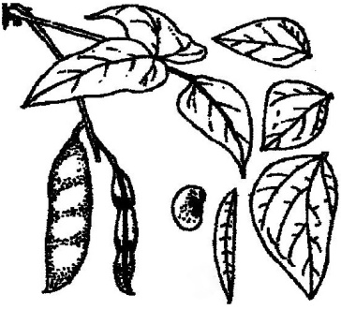
Pigeon Pea (Cajanus cajan)  - very robust legume shrub;  - biennial;  - 2 meters height;  - multipurpose edible grain legume,  living prop for Large Lima Beans, and  feedgrain legume for small chicks. | 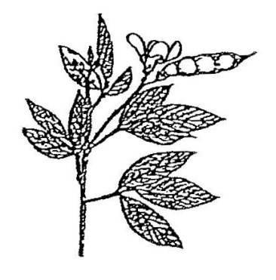
Velvet Bean (Mucuna pruriens)
- herbaceous legume;
- annual;
- aggressive creeper/climber 4 meters long;
- dual-purpose cover crop;
- seeds are not edible.

Gliricidia (Gliricidia sepium)  - very robust legume tree;  - perennial;  - 4 meters height;  - non edible;  - dual-purpose living prop for Large Limas. | 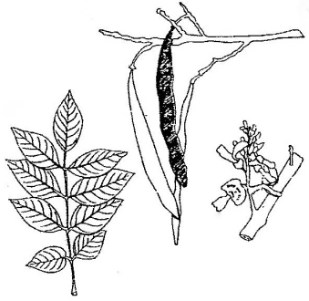
*Bishop, J.; Urizar, R.; Urizar, E.; Chub, A. (2009) Serie de Notas Técnicas para el Trópico Bajo Húmedo:
2. Recolección de Tres Cultivares Perennales de Phaseolus lunatus macrocarpus en el Trópico Bajo Húmedo
Mesoamericano. Tropical Production Systems (www.humidtropics.com).
Commercial seed source: “Large Speckled Lima”, Top Notch Seed, BWI Companies Inc., Nash, Texas 75569, USA.

Slash-and-Mulch Organic Cover on Inter-Row Contour Strips

The practice of slash-and-mulch organic cover on inter-row contour strips
has been shown in the African and American Tropics to provide the
following benefits in tropical soils:*
- Decreases weed propagation;
- Decreases soil temperature which reduces the rate of organic matter
decomposition, thereby ensuring that provision of nutrients to plant roots lasts
longer and is more constant. High soil temperatures can also reduce crop
growth cause death of beneficial soil microorganisms and macroorganisms, and
reduce the required osmotic pressures necessary for absorption of high
concentration of soluble nutrients by plant roots;
- Helps conserve soil moisture;
- Protects soil from high rainfall and helps prevent soil erosion;
- Adds nutrients to the upper layer of soil, where they are more readily available
to plant roots;
- Reduces soil acidity which increases nitrogen and phosphorus availability.

Minimum Tillage in Contour Rows

Minimum tillage in contour rows has been shown in the American and African Tropics to provide the following benefits in tropical soils:**
- Improves the productivity, profitability, and sustainability;
- Decreases loss of soil nutrients;
- Decreases soil compaction;
- Decreases weed propagation;
- Decreases soil erosion. Because of serious erosion problems associated with
intensive tillage, the practice of raised beds should not be used in the Humid
Lowland Tropics;
- Improves soil conservation. With continued long-term use of minimum tillage in
contour rows, contour ridges are gradually formed which further protect soil
from erosion;
- Decreases crop production costs. After 2-4 years, producers are often able to
eliminate most tillage practices. With minimum tillage and with organic matter
increases, soil compaction is reduced and soil structure is improved. Also, as
soil organic matter increases, soil macro-organisms (especially earthworms that
naturally till the soil) also increase, all of which often makes tillage totally
unnecessary (zero tillage).***

___________________
*Bunch, R. (1995) An Odyssey of Discovery: Principles of Agriculture for the Humid Tropics.
ILEIA Newsletter, 11:18-19.
**Primavesi, A. (1982) Manejo Ecológico del Suelo: La Agricultura en Regiones Tropicales.
Editorial Ateneo, Buenos Aires.
***Thurston, D. (1997) Slash/Mulch Systems: Sustainable Methods for Tropical Agriculture.
Westview Press, Boulder, Colorado..

Five-Field Rotation System for Annual Staple Foodcrops
The Five-Field Rotation System for the production of annual staple foodcrops begins with the planting of a new corn field every six months, alternating the Slash-and-Burn Practice at the start of the major wet period in the new field, with the Slash-and-Mulch Practice at the end of the major wet period in the following field. In this way, the slash-and-burn practice is realized in each field only once every 5 years, after 2 rotation cycles of 2½ years (see Figures 10-11).

Figure 10. Five-Field Rotation System for Annual Staple Foodcrops.

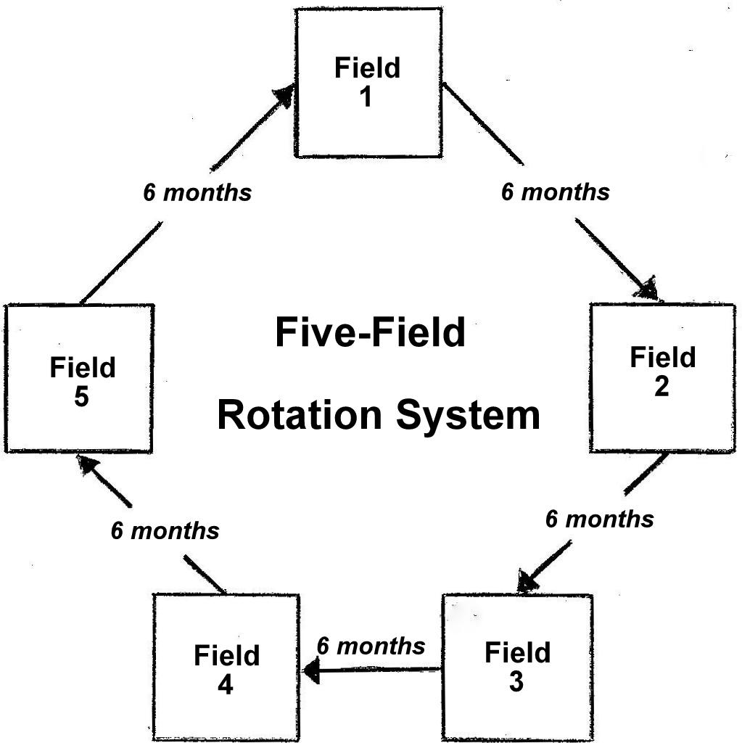

Sequential Rotation of 7 Annual Foodcrops with 4 Fertilizer Legumes

Mixed production of Annual Staple Foodcrops in the Mesoamerican Humid Lowland Tropics usually begins twice-a-year with the planting of Corn in large rotated fields in: Wet-Period Corn Fields at the start of the major rainy period, and Dry-Period Corn Fields at the end of the major rainy period (see Figures 10-11).
During the 1st year, when the mixed production of annual staple foodcrops begins in a new large rotated Wet-Period Corn Field at the start of the major rainy period, FIRST, inter-plant Corn and Squash. SECOND, together with the first weeding of Corn and Squash, over-plant Small Lima Beans every meter using Corn plants as living props. Also, between Corn rows, establish Plantains at 4m x 4m and Large Lima Beans at 4m x 4m using living 1.5m height stakes of Gliricidia as living props. Also, between Corn rows, inter-plant Pigeon Peas at 2m x 4m and Cocoyams at 2m x 2m. THIRD, at the end of the major wet period and after the Corn harvest, inter-plant Cassava and Common Beans with the fertilizer legumes of Pigeon Peas, Gliricidia, and Large Lima Beans already established (see Figures 11-12).
During the 1st year, when the mixed production of annual staple foodcrops begins in another large rotated Dry-Period Corn Field at the end of the major wet period and just before the start of the next major dry period, FIRST, inter-plant Corn and Common Beans. SECOND, after the Corn and Common Bean harvest, inter-plant Cassava and Squash at the start of the following major wet period. Also, inter-plant Large Lima Beans at 4m x 4m using 1.5m stakes of Gliricidia as living props. In addition, inter-plant Cocoyams at 2m x 2m, Pigeon Peas at 2m x 4m, and Plantains at 4m x 4m (see Figures 11-12).

Figure 11. Five-Field/Five-Year Rotation System for the Sequential

Rotation of 7 Annual Staple Foodcrops (Corn, Small Lima

Beans, Squash, Cassava, Common Beans, Plantains, and

Cocoyams) with 4 Fertilizer Legumes (Velvet Beans, Gliricidia,

Pigeon Peas, and Large Lima Beans).*

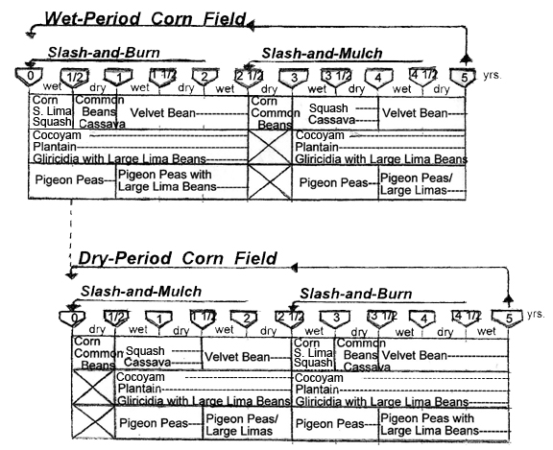

*The Five-Field/Five-Year Rotation System for the Sequential Rotation of 7 Annual Staple Foodcrops with
yrs.
4 Fertilizer Legumes was formulated and prepared by Lic. Rubén Urizar, Director of Instituto Ak' Tenamit
(eur82@yahoo.com) and Dr. John Bishop, Director of Tropical Production Systems
(johnbishop@humidtropics.com) (2002-2011).
During the 2nd year, at the start of the second major wet period with mixed production of annual staple foodcrops, FIRST, over-plant Large Lima Beans beside each Pigeon Pea plant already established in the first year using Pigeon Pea plants as living props. When grown as a biennial and after each dry-period grain harvest, Pigeon Pea shrubs should be pruned-back to 1m height at the start of the next rainy season. Subsequent Pigeon Pea re-growth can then have another productive dry-period grain harvest. SECOND, after the Cassava harvest, inter-plant Velvet Beans at 1m x 2m with the 3 fertilizer legumes of Pigeon Peas and Gliricidia with Large Lima Beans already established in the first year. Velvet Beans can then use as living props the existing Pigeon Pea shrubs and Gliricidia trees. This management practice increases Velvet Bean seed production, as well as facilitates the dry-period Velvet Bean seed harvest (see Figures 11-12).
At the end of the 2nd year, the 4 fertilizer legumes, Large Lima Beans, Gliricidia, Pigeon Peas, and Velvet Beans with the annual staple foodcrops of Plantains and Cocoyams, can all continue in each rotated field for 12-18 months until the reestablishment of the next annual staple foodcrop production cycle (see Figures 11-12). The Gliricidia trees can remain in each rotated field for use in the next annual staple foodcrop production cycle. However, before the planting of the next annual staple foodcrop production cycle, each Gliricidia tree should be pruned-back to a 2m height. When Pigeon Pea shrubs and Gliricidia trees are pruned-back, the pruning provides slash-and-mulch organic cover; and also after the pruning, a similar amount of terminal roots also die-back and biodegrade. The growing and pruning of legume fertilizer shrubs and trees are thus extremely important in helping improve soil nutrients, soil physical structure, and soil organic matter in the Humid Lowland Tropics.

Figure 12. Plant Spacing Diagram for the Mixed Production of the Fertilizer

Legumes Velvet Beans, Gliricidia, Pigeon Peas, and Large Lima Beans

with the Remaining Foodcrops Plantains and Cocoyams at the end of a

2½ Year Crop Rotation Cycle (see Figure 11).

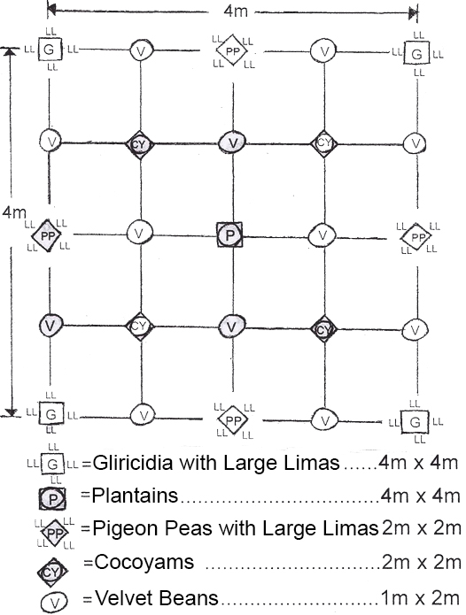

Agro Ethno ecology

Our Life Support System

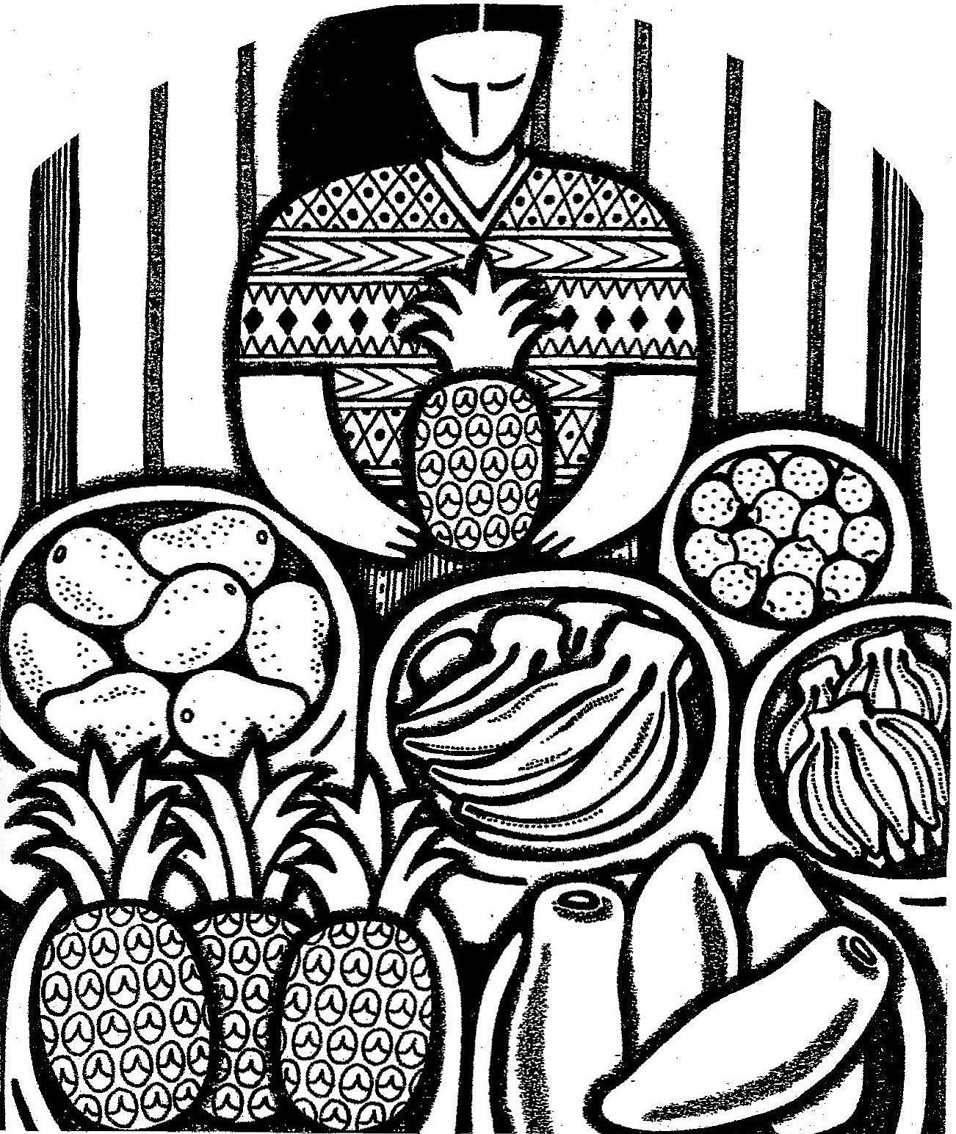

“…Be fruitful, multiply, and replenish the earth…” Genesis 9:1(b)
2. BIENNIAL HORTICULTURAL FOODCROPS
with Small Rotated Plots in Dooryard Gardens
In addition to ANNUAL STAPLE FOODCROPS in Large Rotated Fields, traditional rural families with limited financial resources in the Humid Lowland Tropics also commonly have other production units with BIENNIAL HORTICULTURAL FOODCROPS on Small Rotated Plots in Dooryard Gardens using minimum tillage with slash-and-mulch organic cover (see page 19).*
Many third-world development projects promote the thinking that family diets need more annual fruits and vegetables. This thinking about annual fruits and vegetables is not justified in the Humid Lowland Tropics. Biennial and perennial fruits and vegetables are more numerous in the Humid Lowland Tropics than any other ecological zone.** For example, the Q'eqchi' Maya in the Mesoamerican Humid Lowland Tropics, traditionally cultivate 7 Biennial Horticultural Crops and 21 Perennial Foodcrops and Fruit Trees (see Figure 8). Also, herbal spices and medicinal plants, as well as many plants for traditional household crafts and homestead constructions are commonly cultivated in the dooryard gardens and large permanent orchards.***
Biennial and Perennial Foodcrops and Fruit Trees in the Humid Lowland Tropics can provide an almost continuous production of vitamin and mineral rich foods that are often superior to that of annual vegetables. For example, Bananas, Pineapples, Papayas, and Lemons have better production and nutritional values than many non-traditional non-tropical annual fruits and vegetables (see Figure 13). In dooryard gardens, it is also customary to have commercial production of free-range chickens (see Chapter 3).

Figure 13. Production and Nutritional Levels of Four Selected Biennial and

Perennial Foodcrops in the Humid Lowland Tropics.****

Production Composition
Selected Vitamin A Vitamin C Calcium Iron
Foodcrops (ton/ha) (IU/100g) (mg/100g) (mg/100g) g/100g)

Bananas 50 375 16 9 0.7
Pineapples 42 50 17 17 0.5
Papayas 38 1750 56 20 0.3
Lemons 32 400 31 40 0.4
* Because of serious erosion problems associated with intensive tillage, the practice of raised beds
should not be used in the Humid Lowland Tropics (see Page 19).
** Mortensen, E.; Bullard, E. (1970) Handbook of Tropical and Sub-Tropical Horticulture. USAID, Washington, D.C.
*** Baquero, Walter; Baquero, Wimper; Bishop, John; Kramer, Allyson (1982) SERIE DE EDUCACIÓN AGROPECUARIA: 1. Huerta Casera. INIAP-UFL-ILV Amazonia Ecuatoriana, Imprenta Lingüística, Ecuador.
****Sources: Caribbean Food and Nutrition Institute (1974) Food Composition Tables. Kingston, Jamaica.
Purseglove, J. (1974) Tropical Crops: Dicotyledons. Longman, London.
Purseglove, J. (1975) Tropical Crops: Monocotyledons. Halsted Press, New York.
Biodiverse/Biointensive Priority Management Practices
To improve the production of Biennial Foodcrops on small rotated plots in dooryard gardens, the following Biodiverse/Biointensive practices are recommended.
1) Mixed Production of Biennial Horticultural Crops using Minimum Tillage with Slash-and-Mulch Organic Cover. Many biennial horticultural foodcrops exist in the Humid Lowland Tropics. The Q'eqchi' Maya in Mesoamerica commonly cultivate the following 7 biennial horticultural crops: Hot Peppers, Cherry Tomato, Green Onion, Cilantro, Yampea, Yams, and Okra. These are most often best grown with traditional varieties which are better adapted and more resistant than newly introduced varieties. Also, in many regions, multiple varieties of some biennial horticultural crops often exist.
2) Sequential Rotation of Biennial Horticultural Crops with 3 Fertilizer Legumes. Fertilizer legumes are important because they: (a) improve the chemical, physical, and biological soil composition through increased production of organic matter, nitrogen fixation, and phosphorus accumulation; (b) reduce weed propagation and pest multiplication, and (c) control soil erosion, reduce leeching of soil nutrients, and successfully replace the use of large amounts of costly chemical fertilizers, herbicides, and pesticides. For small rotated plots in dooryard gardens, the following 3 complementary fertilizer legumes exist: Forage Peanut, Pigeon Peas, and Large Lima Beans (see Figures 9 & 14). Forage Peanut should also be used as permanent ground cover between the small rotated plots for erosion control (see pages 17-19).

Figure 14. Three Complementary Multipurpose Fertilizer Legumes for the
Production of Biennial Horticultural Crops.
Forage Peanut (Arachis glabrata)  - herbaceous legume;  - perennial;  - aggressive cover crop for erosion control;  - dual-purpose protein feedcrop for pigs;  - planted like sweet potato. | 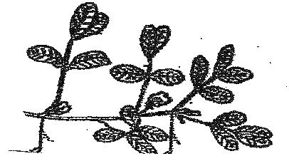
Large Lima Bean (Phaseolus lunatus macrocarpus)  - herbaceous legume;  - biennial;  - aggressive climber;  - 4 meters long;  - dual-purpose edible grain. | 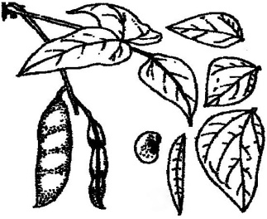
Pigeon Pea (Cajanus cajan)  - very robust legume shrub;  - biennial;  - 2 meters height;  - multipurpose cover crop, edible grain,  living prop for Large Lima Beans, and  protein feedgrain for small chicks. | 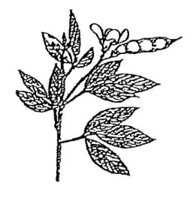
3. COMMERCIAL PRODUCTION OF FREE-RANGE CHICKENS
with Night Shelters in Dooryard Gardens*
Most traditional rural families in the Humid Lowland Tropics have some traditional backyard chickens. Starting with 1 broody hen and 12 fertile eggs, traditional rural families can have a flock of 50 hens in less than 2 years. With backyard chickens, families have important daily egg production which helps improve chronic household protein nutritional deficiencies.
Traditional chickens are also highly valued food animals with good markets which also helps improve family income.** Traditional rural families with 50 hens can produce important family income by selling about 25 older hens and 25 excess cockerels every 3 months! As an important but secondary product,*** traditional rural families also have enough select hatching eggs for natural reproduction of replacement chicks, as well as enough remaining unselected eggs for improving household protein nutrition.****
The most difficult problem many traditional rural families have with traditional backyard chicken production is maintaining flock numbers. They continuously need replacement chicks to compensate for: (a) chickens sold for routine and emergency family expenses, (b) chickens eaten in family meals and social activities, and (c) chickens lost from diseases, predators, thieves, and other calamities.
Importance of Traditional Family Flocks
The importance of traditional family flocks in the production of protein food and household income is frequently overlooked by many development programs.***** Traditional family flocks can multiply more rapidly and be produced with less cost than all other food animals. Also, the egg is the highest quality and least expensive form of animal protein.
_______________
* Sources: Baquero, Walter; Baquero, Wimper; Bishop, John; Bishop, Kay; Kramer, Allyson; Borman, Sheri (1982) SERIE DE EDUCACION AGROPECUARIA: 2. Cría de Gallinas a Nivel Familiar. INIAP-UFL-ILV Amazonίa Ecuatoriana, Imprenta Lingüística, Ecuador.
Bishop, J.; De la Rosa, M. (1998) CRIANZA DE GALLINAS: Guía para Mejorar la Producción a Nivel Familiar en Zonas Tropicales. Cuerpo de Paz, Republica Dominicana.
Firmin, E.; Augustin, O.; Bishop, J. (2000) ELVAJ TI POUL: Gid pou Amelyore ti Poul an Ayiti. Universite Chretiente du Nord D'Haiti, Cap Haitian, Haiti.
Quetee, T.; Freeman, E.; Bishop, J. (2003) Guidelines for Small Farms in the Humid lowland Tropics: 4. Chick Production and Health. Ganta UM & REHAB Mission Stations, Liberia, West Africa.
** Wilk, R. (1997) Household Ecology: Economic Change and Domestic Life among the Kekchi Maya in Belize. Northern Illinois University Press, DeKalb.
*** In most tropical countries, commercial meat production is usually more important than commercial egg production. Even in Western industrialized countries with specialized egg and meat production systems, commercial meat birds outnumber egg birds by more than ten to one!
**** To maintain the commercial production of a traditional family flock of 50 hens, a good plan is to set
2 broody hens every two weeks. The combined hatch can then be traditionally brooded by the hen with the best hatch and the other hen returned back to the laying flock.
***** In fact, Asian-style aquaculture is often promoted. However, even in Asia, poultry production is over
4 times that of inland fish production. This is due to the high elasticity of demand for poultry products.
Poultry products have high nutritional and financial value per unit marketed as well as high Elasticity of demand.* Furthermore, chickens and eggs come in small packages and can be stored in hot climates under local conditions more easily than most foods of animal origin. Eggs can be kept at room temperature without spoilage for 2 weeks. Refrigeration is also not required for preserving chicken meat, as individual chickens can be easily stored alive until slaughtered for consumption.
Traditional family flocks serve as living financial banks with capital increasing in time like interest-earning investments. Furthermore, family flocks provide important household income for children’s medical and educational needs, a ready source of capital for financing on-farm investments, as well as financial and nutritional reserves during periods of adverse climatic fluctuations. Traditional family flocks do not require heavy manual labor and are usually assigned to women and children who normally have fewer off-farm employment opportunities.
Chickens are among the most adaptable food animals, and there are few places in the tropics where climatic conditions prohibit the keeping of a traditional family flock. Probably more people are directly involved in chicken production throughout the world than any other single agricultural enterprise.** In fact, the importance of traditional family flocks often increases as human population density increases. As human population density increases, traditional rural families with limited financial resources tend to place more effort on backyard chicken production in order to diversify and intensify food supply and cash income from their farms; and the absence of a traditional family flock is almost always a sign of extreme poverty!
Traditional chickens also serve socio-cultural functions in celebrations, religious feasts, and holidays. Traditional chickens raised in dooryard gardens also serve agro-ecological purposes by helping control crop pests and by providing high-quality organic fertilizer for foodcrops. Thus, traditional family flocks have nutritional, socio-economical, agro-ecological functions, all of which help improve the family’s survival potential and quality of life!

*In other words, when supply increases, an increased number of chickens will be purchased at similar or
lower prices. Ducks, geese, rabbits, farm-raised fish, and other minor farm animals usually have low
Elasticity of demand with limited market potentials.
**Domestic food producing animals in the world outnumber the human population, two to one. Five species
(chickens, cattle, sheep, pigs, and goats) comprise over 95% of the world’s farm animals and all 5 are
found in the tropics. Of all farm animals in the tropics, however, chickens are by far the most common,
as indeed they are worldwide. The world’s inventory includes 9 billion chickens, 2 billion cattle, 2 billion
sheep, 2 billion pigs, and 1 billion goats.

Strategic Importance of Egg Protein for Small Children

Small children between 1-3 years are most vulnerable to protein malnutrition, defined as a low-protein diet causing irreversible physical and mental retardation. Furthermore, weakened by protein malnutrition, their bodies are highly susceptible to infectious diseases.*
Malnourished children have up to 50% higher incidence of diarrheal disease and suffer more severe attacks of respiratory infections than well-nourished children. Diarrheal diseases are especially critical in that they also inhibit the absorption of nutrients, causing further malnutrition. Diarrheal disease has long been recognized as the major cause of death for small children in the tropics.
In addition, diarrheal and respiratory infections further increase protein requirements because of need to repair tissue damaged by infections. Protein malnutrition associated with repeated diarrheal and respiratory infections form the greatest hazard to the health of small children in the tropics!
The vicious cycle of protein malnutrition and repeated infection ends in fatal infections in an estimated 30% of children in the tropics under 3 years.** In addition, many children that survive this vicious cycle still face permanent physical and mental retardation. This vicious cycle can be broken only by provision of a diet adequate in protein. The chicken egg is the highest quality and least expensive form of animal protein!
Protein requirements have been traditionally expressed in terms of total grams of protein needed. However, with better knowledge of protein metabolism, the trend is now to recommend quantities for each essential amino acid rather than total grams of protein needed.*** This approach is logical as dietary proteins are broken down to their component amino acids in the gastrointestinal tract before absorption into the bloodstream.
The sulfur-containing amino acids (methionine & cystine) are the essential amino acids found to be first limiting in most tropical foods and diets.**** In fact, one egg can supply over 1/3 the total protein and over ½ the methionine & cystine required daily by a child between 1-3 years of age!*****
Chicken eggs are also an easily prepared and highly-digestible protein-rich food for small children from the age of 6 months onward. As a first priority, eggs should be fed to small children less than 3 years. Chicken meat is also a highly-digestible and high-quality protein-rich food for the entire family.
____________________
*Small children between 1-3 years are most vulnerable to protein malnutrition and repeated infections, as they:
(a) have very high protein requirements (1.2 g protein/kg body wt/day), (b) no longer receive sufficient quantities of
breast milk, (c) become fully susceptible to childhood diseases from which they were partially immune during early life,
and (d) become more active which increases their exposure to childhood diseases.
**Especially from common gastrointestinal and respiratory diseases, which in properly nourished children would not be
particularly serious.
***Sources: FAO/WHO (1973) Nutrition and Health SERIES: 7. Energy and Protein Requirements. Rome.
FAO (1970) Nutrition SERies: 24. Amino Acid Content of Foods & Biological Data on Proteins. Rome.
****In fact, kwashiorkor due to protein deficiency is most common where young children are weaned onto cassava. Even
though cassava has lower quantity and quality protein than most food crops, it is important to note that its popularity
as a staple food is increasing rapidly in many tropical countries, as it grows better and out produces other food crops
on less fertile soils.
*****With an average body weight of 12 kg.

Nutrition Plus Income
Traditional family flocks are thus extremely important in helping interrupt the vicious cycle of poverty, malnutrition, disease, physical/mental retardation, and enduring poverty prevalent in most tropical countries. Not only do eggs provide essential amino acids for improved health and better physical & mental development of small children, but the sale of live chickens also provides important family income often used by the mother to cover children’s medical and educational needs.
Therefore, improving the production of traditional family flocks has strategic importance in helping meet the family’s health, nutritional, and financial objectives. The cow is often said to be the mother of civilization. However, for many traditional rural families with limited financial resources, the chicken must be a close relative!

Background on Poultry Production in Tropical Countries
Poultry production systems in tropical countries are of two distinct types: (1) Larger Agro-Industrial Confinement Systems with high financial inputs and (2) Smaller Traditional Free-Range Systems with low financial inputs.
Confinement technologies favor large-scale Agro-Industrial/Capital-Intensive broiler and egg production. These Agro-Industrial/Capital-Intensive management practices become more-and-more cost-effective as production size increases, and smaller confinement farms have more-and-more difficulty competing. In fact, specialized Agro-Industrial/Capital-Intensive confinement systems work most effectively by the truckload, purchasing inputs by the truckload and marketing outputs by the truckload.
With such Agro-Industrial/Capital-Intensive competition, many people often erroneously conclude that traditional rural families cannot economically raise chickens! Traditional family flocks can economically out-compete Agro-Industrial/ Capital-Intensive confinement systems when using low-cost traditional free-range production systems.
Agro-Industrial/Capital-Intensive confinement systems require high-tech balanced feed and are food converters rather than food producers, and in the conversion process much protein is lost. Intensive broiler and egg production systems in fact are false food-production systems which consume more than 3 grams of food-grain protein for each gram of animal protein produced!
Agro-Industrial/Capital-Intensive confinement systems have Economic Comparative Advantages for large-scale production, and it is unwise to apply them on traditional family farms. The application of Agro-Industrial/Capital-Intensive confinement systems on traditional family farms have been repeatedly tried around the world for many years. The results most often obtained with a few hundred chickens per farm have been economic failures. Today, one can find many buildings empty, chickens gone, money lost, and hopes dissipated.
Agro-Industrial/Capital-Intensive confinement systems are found near many urban areas in the tropics. These systems are essentially an urban phenomenon financed by urban capital, and mainly benefiting a few large-scale urban enterprises Such peri-urban enterprises are generally patterned after Western models with a high degree of specialization, and most often do not grow their own feed.
It must be emphasized that large-scale, capital-intensive, confinement systems have not replaced traditional free-range systems in the myriad of traditional family farms throughout the tropics; and that countless millions of traditional rural families still depend on low-input free-range production systems for supply of meat and eggs! With increasing costs of energy and purchased feed supplies, traditional free-range systems continue to have nutritional and economic validity.

Priority Management Practices for Commercial Family Flocks

Traditional rural families have Economic Comparative Advantages for commercial production of free-range chickens in the humid lowland tropics. This is largely due to their comparative advantage to use traditional chickens with free-range management as well as their ability to produce low-cost/year-round/on-farm robust perennial feedcrops such as Blugoe Bananas, Finger Bananas, Apple Bananas, and Pigeon Peas.

Most traditional rural families can produce sufficient year-round robust perennial feedcrops, have sufficient area for year-round free-range management, and have ample local construction materials to build a protected night shelter for a commercial traditional family flock of up to 50 hens. A protected night shelter should have about 10m² for a flock of 50 adult hens (1m² / 5 hens).

To improve the commercial production of traditional family flocks, the following priority management practices should be used.

1) Use of Traditional Chickens.

Agro-Industrial/Capital-Intensive broiler and layer strains have been especially developed for large-scale confinement systems. They only perform well when given costly balanced-feeds, extended lighting, and bio-security measures for disease prevention. Therefore, they are economically best-suited for large-scale production and marketing systems.

Agro-Industrial/Capital-Intensive broiler and layer chickens along with artificial incubation and artificial brooding were developed in non-tropical countries, where large seasonal-changes in daylight and temperature produce seasonal fluctuations in poultry production. Agro-Industrial feed industry was also developed in non-tropical countries to allow chicks to be raised in confinement during colder months. These developments, along with artificial lighting and high-tech disease control, allows for year-round agro-industrial poultry production in non-tropical countries.

Traditional chickens, however, are still very appropriate for tropical countries because large seasonal-changes in day length and temperature do not occur. Therefore, traditional family flocks in tropical countries can continuously utilize free-range production systems which facilitate low-cost year-round poultry production for traditional rural families.

Traditional chickens require few financial inputs. Low-cost replacement chicks for traditional family flocks are hatched, brooded, and protected by traditional hens. For thousands of years, traditional rural families have had triple purpose hens which: (1) hatch and brood chicks, (2) produce meat, and (3) lay eggs. Today, for traditional third-world rural families, the first two are more important as live traditional chickens are highly valued food animals with high elasticity of demand that produce important family income (see Figure 15).

Figure 15. Comparative Analysis of Traditional & Agro-Industrial Chickens

for Rural Families in the Humid Lowland Tropics.*

Points Analyzed Traditional Chickens Agro-Industrial Chickens

Chick Costs Low High
Feed Costs Low High
Mortality Rates Low High
Meat Production Average Average
Egg Production Average High
Elasticity of Demand High Average
Natural Incubation High Low
Natural Brooding High Low

*The Comparative Analysis was formulated and prepared by Kay Bishop, Walter Baquero,
Sheri Borman, Bertha Mamallacta, and John Bishop. INIAP-UFL-ILV Amazonίa Ecuatoriana
(1975-1982).

It is extremely difficult for traditional rural families to maintain flock numbers and replace chickens which are sold, eaten, and lost if traditional rural families cannot produce replacement chicks on their own. Buying and raising agro-industrial chicks are expensive and can be disastrous for traditional rural flocks. Agro-industrial chicks require artificial incubation and artificial brooding, and only perform well when given costly balanced feeds; all of which are not financially feasible for most traditional rural families. All these effects are serious, but the loss of a traditional family flock’s ability to hatch and brood replacement chicks by natural reproduction is extremely serious!

In many tropical regions, the drastic introduction of high-tech Agro-Industrial/Capital-Intensive broiler and layer chickens has proven inappropriate for traditional family flocks. They are inferior to the hardy, well-adapted, traditional chickens in family flocks. The greatest danger from the introduction of Agro-Industrial/Capital-Intensive broiler and layer chickens, however, is that when Agro-Industrial roosters indiscriminately cross with traditional hens, the resultant crosses most often lack the ability to hatch and brood replacement chicks by natural reproduction, which is so important for traditional family flocks.

When agro-industrial roosters cross with traditional hens, traditional family flocks can lose the ability to hatch and brood chicks in just one generation. This can quickly make the family dependent on costly replacement agro-industrial chicks, which are not only expensive but also, do not perform well in traditional low-cost free-range production systems; and therefore are not cost effective for traditional rural families. Natural reproduction is very appropriate for traditional family flocks and should be maintained and improved wherever possible.

In many areas of the tropics today, many traditional family flocks are on the decline because families cannot afford to buy and raise costly replacement agro-industrial chicks, and many remaining local hens lack the ability to naturally incubate and brood replacement chicks due to cross-breeding with high-tech agro-industrial roosters. In traditional family flocks where this has occurred, it is best to reintroduce appropriate traditional chickens from other local family flocks. One can also buy traditional naked-neck red chicks at some agricultural supply stores supplied by the Santa Rosa Hatchery in Guatemala City (www.santarosa@itelgua.com) which are from parent stock imported from the Sosa Hatchery in France (www.sasso.fr.com).

2) Use of Robust Perennial Feedcrops and Free-Range Management.

Low-input free-range management systems are the norm for traditional family flocks in the tropics. Traditional rural families have economic comparative advantages for commercial production of free-range chickens in the Humid Lowland Tropics. This is due to their use of traditional chickens, free-range management, and their ability to produce low-cost, year-round, on-farm, robust perennial feedcrops.* The economic efficiency of backyard chicken production for traditional rural families lies in the fact that there are few purchased inputs, and the gross income received from the sale of each chicken is virtually the net income.

Traditional chickens with free-range management are usually able to meet their protein, vitamin, and mineral requirements from herbage, weeds, seeds, insects, worms, soil microorganisms, and macroorganisms. However, traditional hens usually don’t have enough digestible energy for adequate egg production. Therefore, the first limiting nutrient in traditional free-range systems is energy.

As the first limiting-nutrient for traditional free-range chickens is energy, robust Banana varieties should be chosen as the major year-round perennial feedcrop in the humid lowland tropics. Robust Bananas are very vigorous perennial crops and have the lowest production cost and use the smallest land area per unit of energy produced of all tropical feedcrops.** Only ripe high-moisture Bananas should be fed to chickens because green low-moisture Bananas have lower levels of consumption and digestibility, and in warmer climates chickens need more water. Ripe Bananas contain about 90% the energy value of corn.*** Weight gains will not be as high, but it is a positive economic trade-off. With the sale of older hens and excess cockerels, growth rate is not a factor in the total amount of income produced, but only a factor of time. The same number of older hens and younger cockerels can reach about the same market weights without additional cost; it just takes a little longer. In these low-input systems, time is not money! When traditional hens with free-range management are fed supplemental ripe Bananas, daily egg production can increase from 20-25% to 40-50%. Low-cost/on-farm/year-round feedcrop production is extremely important for traditional rural families.

However, both energy and protein supplemental feeds are important for smaller traditional free-range chicks less than 1 month of age. An on-farm produced energy/protein feed can be made by mixing 80-90% ripe Bananas with 10-20% ground Pigeon Pea grain.**** (see Figures 12,14,17,18) Supplemental energy/protein feed should be selectively given in creep feeders that are protected from larger free-range chicks more than 1 month of age (see Figure 16).
____________________
*By comparison, the use grain-based balanced-feeds account for about 80% of Agro-Industrial
poultry production costs!
**Johnson, B. (1958) Staple Food Economics of West Africa. Stanford University Press. California.
***Caribbean Food and Nutrition Institute (1974) Food Composition Tables. Kingston, Jamaica.
****Pigeon Pea grain has higher levels of total protein with deficient amino acid levels of methionine
and cystine, while ripe bananas have lower levels of total protein with excess amino acid levels of
methionine and cysteine. For more information on methionine and cystine see page 30.

Figure 16. Protected Creep-Feeder for Smaller Free-Range Chicks.

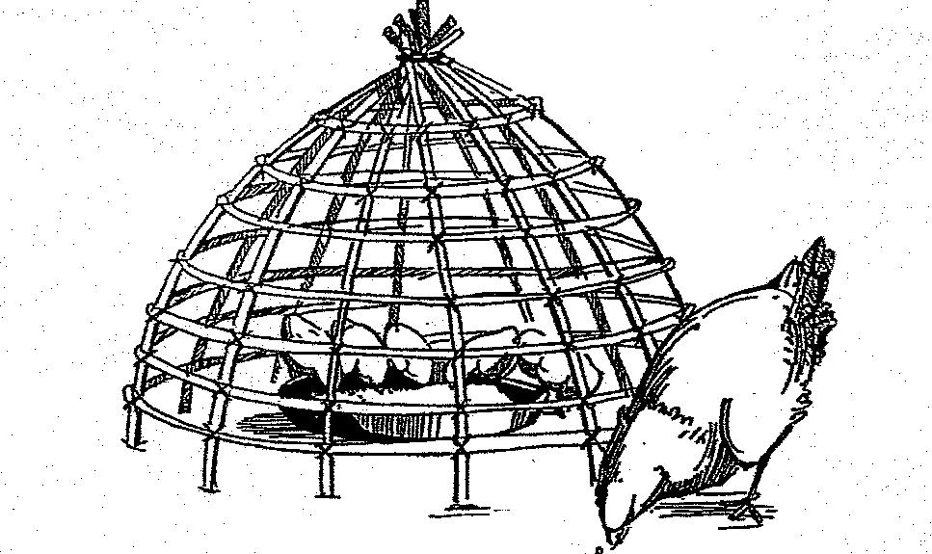

3) Newcastle Vaccination and Internal Parasite Medication.

Newcastle Vaccination. The Newcastle disease virus is highly infectious and causes more mortality than all other poultry diseases in the tropics. When Newcastle virus strikes, it spreads rapidly throughout the flock and mortality can reach 100% in a few days. First signs are usually respiratory problems such as gasping, coughing, sneezing, and hoarse chirping. A greenish diarrhea may also be present. No treatment is known. Newcastle disease can only be prevented by vaccination.* The entire flock including small chicks should be vaccinated every 6 months. Newcastle vaccine can be purchased at agricultural supply stores.
Internal Parasite Medication. Internal parasites, especially roundworms are a very common problem in free-range production systems. Roundworms cause reduced growth, lowered egg production, and increased susceptibility to other diseases. Traditional family flocks with heavy roundworm infestations have more severe disease outbreaks and suffer more attacks than dewormed flocks. One roundworm can produce up to 5,000 eggs which other chickens pick-up from fecal contamination. Younger chicks (like small children) are more seriously affected by internal parasites and some may even die. The most widely used product to prevent losses from roundworms is oral piperazine. Chicks from 1 to 3 months of age should be dewormed every 30 days. Oral piperazine or similar deworming medicines can be purchased at agricultural supply stores.
____________________
*Ministerio de Educación (2008) Manual de Producción Pecuaria: Modulo de Capacitación para
Practicas Pecuarias. Dirección General de Educación Extraescolar, Guatemala.

4. PERENNIAL FOODCROPS & FRUIT TREES
in Large Permanent Orchards
In addition to ANNUAL STAPLE FOODCROPS in Large Rotated Fields and BIENNAL HORTICULTURAL FOODCROPS on Small Rotated Plots in Dooryard Gardens, traditional rural families with limited financial resources in the Humid Lowland Tropics also commonly have other production units with PERENNIAL FOODCROPS & FRUIT TREES in Large Permanent Orchards.*
In the Humid Lowland Tropics, large permanent orchards traditionally have many perennial foodcrops and fruit trees which are generally organized vertically as well as horizontally, to optimize utilization of available space and sunlight. These multi-story perennial foodcrops and fruit trees provide families with an increased variety of highly nutritious foods as well as additional income (see Figure 13). Large permanent orchards can also be integrated with commercial chicken and pig production (see Chapters 3 & 5).
Perennial foodcrops and fruit trees have low financial and managerial requirements. Perennial foodcrops and fruit trees have a higher ratio of nutrients stored in their organic matter compared to those nutrients stored in the soil. This helps reduce soil erosion and helps insure more efficient nutrient recycling with less total nutrient loss. The soil nutrient and moisture levels are also increased by the uptake of minerals and water through deeply-rooted perennial foodcrops and fruit trees. Perennial foodcrops and fruit trees are also less affected by climatic variations, which help improve food security in the Humid Lowland Tropics. Some robust perennial foodcrops (for example, Apple Banana, Finger Banana, Blugoe Banana, Pigeon Pea, Forage Peanut) can also produce large quantities of year-round/low-cost/high-energy/high-protein feeds for the commercial production of chickens and pigs (see Chapters 3 & 5).
Biodiverse/Biointensive Priority Management Practices
To improve the production of Perennial Foodcrops and Fruit Trees in Large Permanent Orchards, the following Biodiverse/Biointensive priority management practices are recommended.
1) Mixed Multi-Story Production of 13 Fruit Trees and 8 Perennial Foodcrops. Many fruits trees and perennial foodcrops exist in the Humid Lowland Tropics. The Q'eqchi' Maya in Mesoamerica traditionally cultivate the following 12 fruit trees: Local Lemon, Local Orange, Sweet Lime, Dwarf Coconut, Rampur Lime, Local Grapefruit, Local Avocado, Sweetsop, Guava, Breadnut, Soursop, Breadfruit, and Pejibaye. These fruit trees can be directly planted using locally harvested seeds (with the exception of the seedless breadfruit which is multiplied using root-suckers). These are most often best grown with local traditional varieties which are better-adapted and more-resistant. The mixed multi-story production can be further intensified with the mixed inter-cropping of the following 8 perennial foodcrops: Apple Banana, Finger Banana, Blugoe Banana, Sugar Cane, Taro, Sweet Potato, Papaya, and Pineapple.
__________________
*Sources: Mortensen, E.; Bullard, E. (1970) Handbook of Tropical and Sub-Tropical Horticulture. USAID, Washington.
Weatherford, J. (1988) INDIAN GIVERS: How the Indians of the Americas Transformed the World.
Crown Publishers, New York.
2) Mixed Production of 4 Fertilizer Legumes. The perennial foodcrops and fruit trees can be further intensified with the intercropping of the following 4 multipurpose food/feed/forage/fuelwood/fertilizer legumes: Flat Guamos, Round Guamos, Pigeon Peas, and Forage Peanut (see Figures 17-18). Also, herbal spices and medicines, as well as many traditional plants for household crafts and homestead constructions are commonly cultivated in large permanent orchards.

Figure 17. Four Multipurpose Food/Feed/Forage/Fuelwood/Fertilizer Legumes

for the Production of Perennial Foodcrops and Fruit Trees.

Flat Guamos (Inga spp.)  - robust legume tree;  - perennial;  - 4 meters height;  - multipurpose fuel wood  and edible fruit legume. | 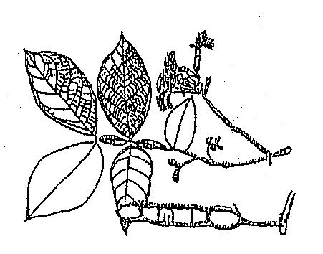
Round Guamos (Inga spp.)  - fast-growing legume tree;  - perennial;  - 4 meters height;  - multipurpose fuel wood  and edible fruit. | 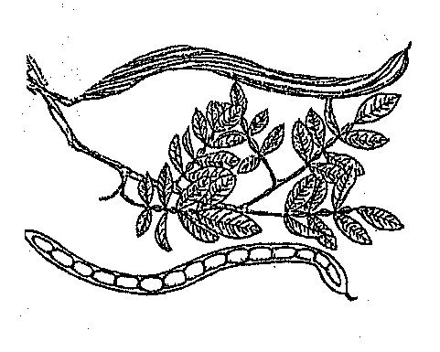
Pigeon Peas (Cajanus cajan)  - very robust legume shrub;  - biennial;  - 2 meters height;  - multipurpose edible foodgrain  and protein feedgrain for small chicks. | 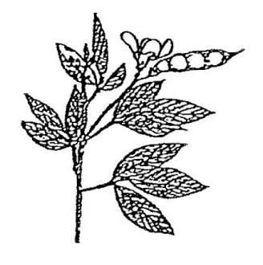
Forage Peanut (Arachis glabrata)
- herbaceous legume;
- perennial;
- aggressive cover crop;
- dual-purpose protein feedcrop for pigs;
- planted like sweet potato.
3) Mixed Production of 5 Perennial Feedcrops for Chickens and Pigs. The mixed multi-story production can be further intensified with the additional intercropping of Robust Perennial Multipurpose Feedcrops for chickens and pigs: Apple Banana, Finger Banana, Blugoe Banana, Pigeon Peas, and Forage Peanut (see Figure 18 and Chapters 3 & 5).

Figure 18. Plant Spacing Diagram for the Mixed Multi-Story Production of

Fruit Trees, Robust Perennial Multipurpose Foodcrops, Fertilizer

Legumes, and Physic Nut for tethering pregnant and lactating sows.

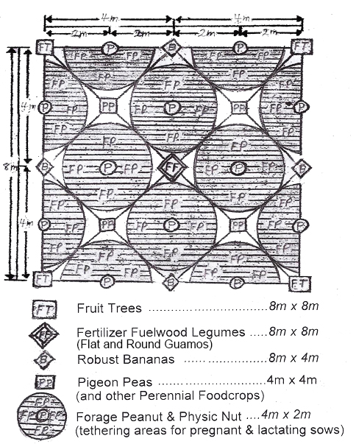

5. COMMERCIAL PRODUCTION OF TETHERED & PENNED PIGS
in Large Permanent Orchards*
Development programs frequently overlook the importance of commercial pig raising for the production of high quality protein food and income generation for traditional rural families with limited economic resources on less-fertile hill-lands in the Humid Lowland Tropics. Pigs have high nutritional and financial value per unit of product marketed as well as high Elasticity of demand. Pigs can also reproduce more rapidly and can be produced with less cost than ruminant livestock.
Whereas grazing ruminant livestock (cattle, meat goats, hair sheep) were domesticated in dryer temperate savannah regions of Eurasia, while pigs and chickens were domesticated in the Humid Lowland Tropics of Southeast Asia. One should note that when ruminant livestock production expands into the Humid Lowland Tropics, large regions are often deforested and converted into extensive ranchland, which can cause severe socio-economic** and agro-ecological*** problems (see Pages 7-11).
Traditional rural families have Economic Comparative Advantages for pig production in the Humid Lowland Tropics. This is largely due to their comparative advantage to produce low-cost, year-round, on-farm, robust perennial feedcrops. The economic efficiency of pig production for such traditional rural families lies in the fact that there are few purchased inputs, and most of the gross income received from sale of each full-grown market hog is virtually the net income.
Priority Practices for Pig Production on Traditional Family Farms
To improve the commercial pig production of traditional families in the Humid Lowland Tropics, the following priority management practices should be used.
1) Use of Robust Perennial Feedcrops for Energy and Protein.
A major constraint limiting the expansion of commercial pig production for rural families in the Humid Lowland Tropics is insufficient low-cost/year-round/on-farm feed production. Traditional rural families can produce sufficient robust perennial feedcrops (for example, Apple Banana, Finger Banana, Blugoe Banana, Forage Peanut) to maintain 12 sows and produce 60 full-grown market hogs per year! (see Figures 17-19)
*Sources: Bishop, J. (1979) Producción Familiar Agro Porcino Forestal en el Trópico Húmedo Hispanoamericano.
Taller sobre Sistemas Agro Forestales en América Latina Tropical, CATIE-UNU, Turrialba, Costa Rica.
McDowell, R.; Hilderbrand, P. (1980) INTEGRATED CROP AND ANIMAL PRODUCTION: Making the Most
of Resources Available to Small Farms in Developing Countries. Working Papers, Rockefeller Foundation,
New York.
Sprague, H. (1976) Combined Crop/Livestock Farming Systems for Developing Countries of the Tropics
and Subtropics. Technical Series Bulletin No19, USAID, Washington D.C.
Baquero, Walter; Baquero, Wimper; Bishop, John; Kramer, Allyson; Borman, Sheri (1983)
SERIE DE EDUCACIÓN AGROPECUARIA: 3. Cría de Chanchos a Nivel Familiar.
INIAP-UFL-ILV Amazonía Ecuatoriana, Imprenta Lingüística, Ecuador.
**Grandia, L. (2006) UNSETTLING: Land Dispossession and Enduring Inequity for the Q'eqchi' Maya
in the Guatemalan and Belizean Frontier Colonization Process. Ph.D. Anthropology Dissertation,
U. C. Berkeley, California.
***Bishop, J. (1984) The Dynamics of the Shifting Cultivation, Rural Poor, Cattle Complex on Marginal Lands
in the Humid Tropics. In: Social, Economic, and Institutional Aspects of Agro-Forestry, NRTS-23/UNUP-502,
United Nations University, Tokyo, Japan.
As the first limiting-nutrient for traditional pig production is energy, robust Bananas should be produced and used as the major energy feed in the Humid Lowland Tropics. Robust Bananas have year-round production, have the lowest production cost, and use the smallest land area per unit of energy produced of all tropical feedcrops.* Ripe Bananas contain about 90% the energy value of corn.** Weight gains will not be as high, but it is cost-effective, and thus, a positive economic trade-off. With the sale of full-grown market hogs, growth rate is not a factor in the total amount of income produced, but only a factor of time. The same number of full-grown market hogs can reach about the same market weight without additional out-of-pocket expense; it just takes a little more management time (sweat equity). In these low-input systems, time is not money!
Low-cost on-farm feedcrop production is extremely important for traditional rural families as balanced grain-based commercial feeds account for 80% of large-scale agro-industrial pig production costs. Only ripe high-moisture Bananas should be fed to pigs because green low-moisture Bananas have lower consumption and digestibility; and also because in warmer climates, pigs need more water. As the second limiting nutrient for traditional pig production is protein, Forage Peanut should also be produced and used as the major protein supplement in the Humid Lowland Tropics. Forage Peanut is a very robust perennial feedcrop with year-round production, and is the most economical on-farm produced protein supplement for pig production in the Humid Lowland Tropics. (see Figures 17-19)

Figure 19. Use of Perennial Bananas for Energy Feed and

Perennial Forage Peanut for Supplemental Protein Feed.
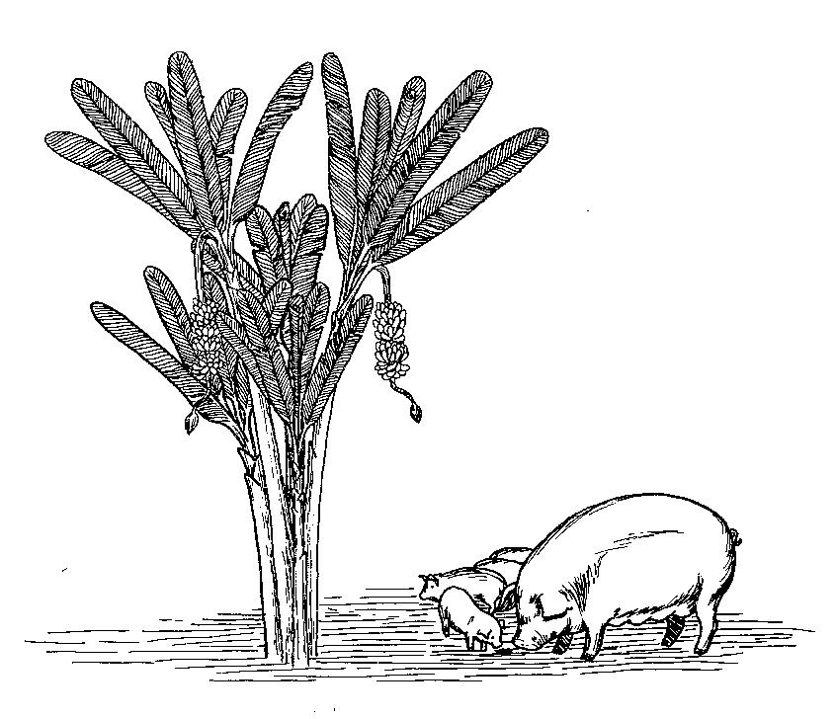
____________________
*Johnson, B. (1958) The Staple Food Economics of West Africa. Stanford University Press, California.
**Caribbean Food and Nutrition Institute (1974) Food Composition Tables. Kingston, Jamaica.

2) Use of Tethering Areas for Pregnant/Lactating Sows & Pens for Weaned Pigs.
For pig production in the Humid Lowland Tropics, traditional rural families can use tethering areas for pregnant and lactating sows (see Figure 18), as well as pens for feeder pigs and breeder males. Pig pens should have 1m² for each large pig. Each pregnant and lactating sow can be rotationally tethered around living stakes of Physic Nut. They can be rotationally grazed (1 week of grazing followed by 4-6 weeks without grazing) on areas with Forage Peanut and be hand-fed ripe Bananas. At weaning, the piglets should be moved to feeder pens and hand-fed ripe Bananas and Forage Peanut. At weaning, each sow should be moved to a breeder pen with an improved breeder male. When sows become pregnant they should return to the tethering areas.
3) Hog Cholera Vaccination and Internal Parasite Medication.
Hog Cholera Vaccination. Pigs with Hog Cholera have severe diarrhea and they vomit. They have a high fever and sticky discharge from the eyes which pastes the eyelids together. Often the tips of the ears and tail become black. Some pigs have brown patches on the abdomen, head, and legs. Most pigs die. Hog Cholera can be prevented only by vaccination. Sows and piglets should be vaccinated at weaning. Hog Cholera Vaccine can be purchased at agricultural supply stores.
Internal Parasite Medication. Internal parasites, especially roundworms, cause reduced growth, diarrhea, and increased susceptibility to other diseases. Younger pigs (like smaller children) suffer more from internal parasites and some may die. It is important to deworm all piglets at weaning and again every 2 months until pigs are 6 months old. Injectable Ivermectin is recommended as it controls both internal and external parasites.* Oral Piperazine can also be used. Deworming medicine can be purchased at agricultural supply stores.
Figure 20. Injection of Hog Cholera Vaccine and Ivermectin Dewormer.

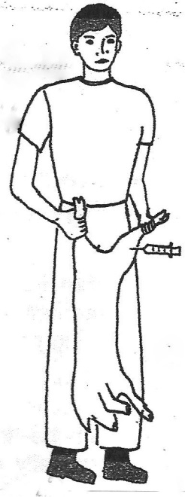
____________________
*Ministerio de Educación (2008) Manual de Producción Pecuaria: Modulo de Capacitación para
Practicas Pecuarias. Dirección General de Educación Extraescolar, Guatemala.
6. COMMERIAL PRODUCTION OF TIMBER & COCOA TREES
in Large Enriched Forests
In addition to COMMERCIAL PRODUCTION OF FREE-RANGE CHICKENS with Night Shelters in Dooryard Gardens and COMMERCIAL PRODUCTION OF TETHERED & PENNED PIGS in Large Permanent Orchards, many traditional rural families with limited economic resources on less-fertile hill-lands in the Humid Lowland Tropics also have other units with COMERCIAL PRODUCTION OF TIMBER & COCOA TREES in Large Enriched Forests.
To improve the Commercial Production of Timber and Cocoa Trees* in Large Enriched Forests for traditional rural families, the following priority Biodiverse/ Biointensive management practices should be used.
1) Mixed Multi-Story Production of Timber (10m x 10m) & Cocoa (5m x 5m)Trees.
The best timber trees to plant in the Humid Lowland Tropics are the native commercial timber trees commonly found in each region. Native timber trees are more resistant and better adapted than introduced timber trees.**
The best native commercial timber trees for mixed multi-story production in large enriched natural forests in the region of Izabal, Guatemala are: Spanish Cedar (Cedrela odorata), Mahogany (Swietenia microphylla), Yellow Wood (Terminalia amazonia), Laurel (Cordia alliodora), Lemonwood (Calophyllum brasiliense), and White Mahogany (Vochysia guatemalensis). Of these native timber trees, Lemonwood is the fastest growing, and is also used both for saw wood and round wood. Botanical drawings of the 6 native timber trees are presented in Figures 22-23.
Native timber trees can be planted each year during the major annual wet period using seedlings from local natural regeneration. Local native seedlings of Spanish Cedar, Mahogany, Yellow Wood, and Laurel can be transplanted using short root-stumps (see Figure 21).*** Local native seedlings of Lemonwood and White Mahogany should be transplanted using small natural seedlings that are about 25-50 cm tall and with about ½ of their lower leaves removed.
Transplanting seedlings by short root-stumps greatly reduces transplant stress which increases both survivability and subsequent growth. Transplanting local natural seedlings by short root-stumps also greatly reduces nursery and transportation costs. Within a few months following transplanting, several new sprouts can often be found growing near the top of some short root-stumps. At about 6 months, physically break-off all the smaller multiple sprouts and leave only the largest sprout to form a single trunk for each new tree.
2) Sequential Intercropping of Robust Bananas (2.5m x 2.5m) for Chickens & Pigs.
In the first few years after planting timber and cocoa trees, the land can be further intensified with the sequential multi-story intercropping of Apple Banana, Finger Banana, and Blugoe Banana for chicken and pig feed (see Chapter 3 & 5). _______________
*In the Humid Lowland Tropics, higher quality coffee is grown at elevations above 600 m, while higher
quality cocoa is grown at elevations below 600 m.
**Peck, R.; Bishop, J. (1992) Management of Secondary Tree Species in Agroforestry Systems to
Improve Production Sustainability in Amazonian Ecuador. Agroforestry Systems, 17:53-63.
***Calvo, G.; Meléndez, L. (1999) Pseudoestacas de Laurel para el Enriquecimiento de Cacaotales.
Agroforesteria en las Américas, 22:25-27.

Figure 21. Short Root-Stumps for Transplanting Native Timber Seedlings

from Annual Natural Regeneration.

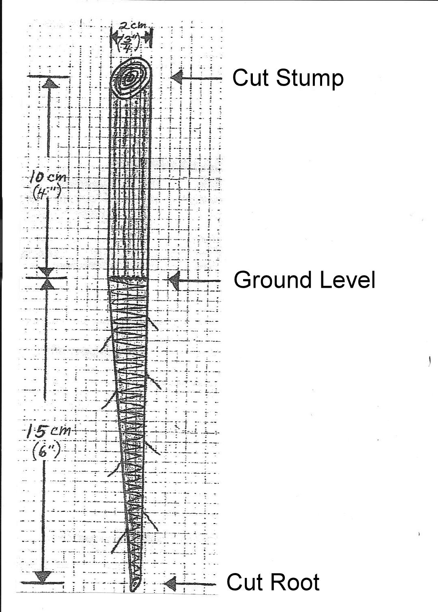

Figure 22. Four Native Timber Trees which can be Transplanted using

Short Root-Stumps from Annual Natural Regeneration.

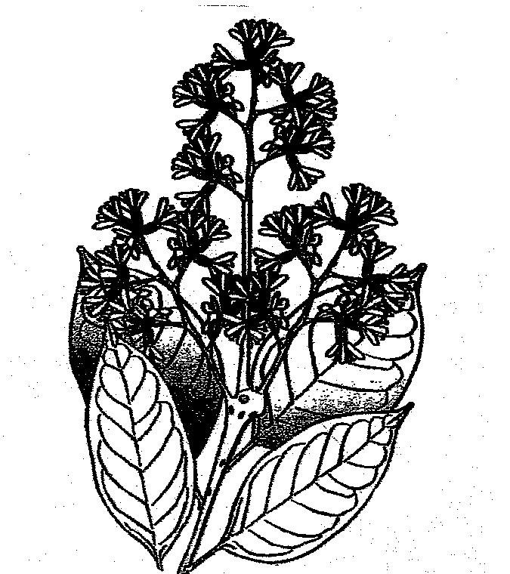 | 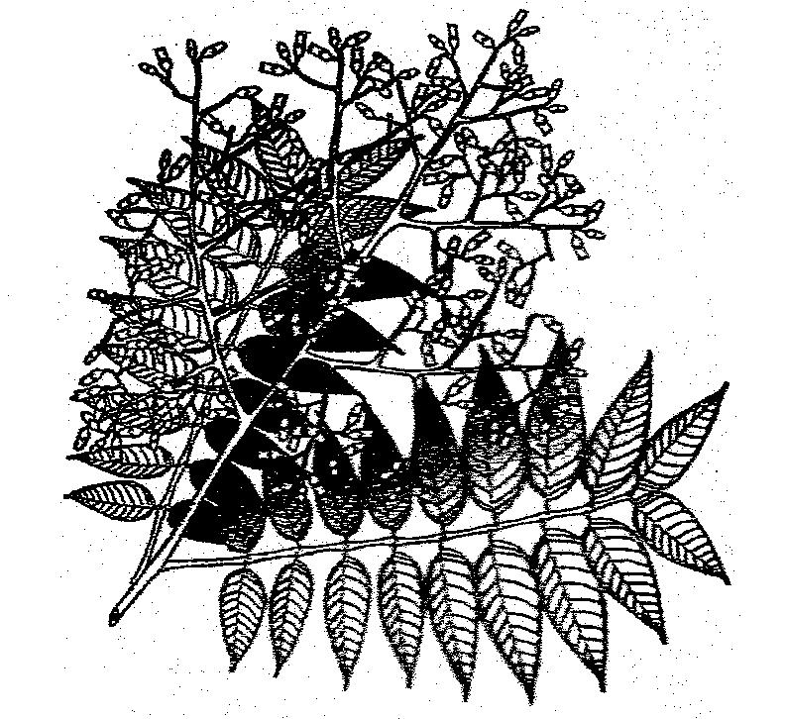
Laurel (Cordia alliodora) | Spanish Cedar (Cedrela odorata)
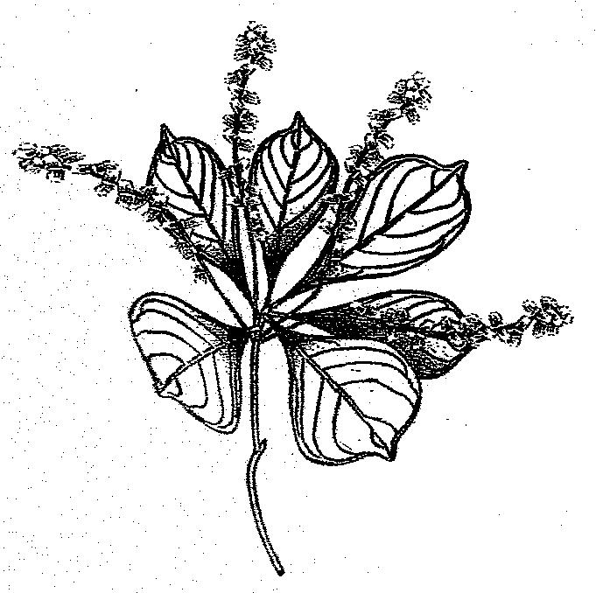  Yellow Wood (Terminalia amazonia) | 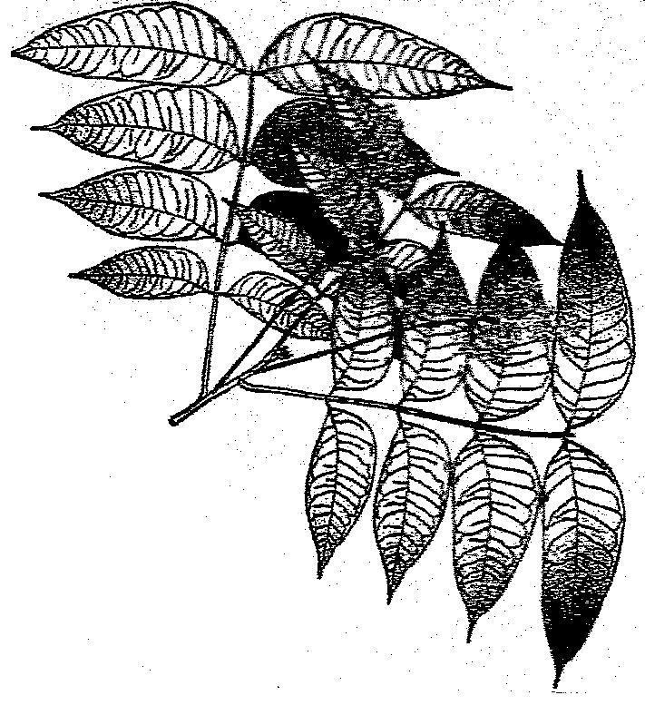  Mahogany (Swietenia macrophylla)

Figure 23. Two Native Timber Trees which should be Transplanted using
Small Seedings from Annual Natural Regeneration.
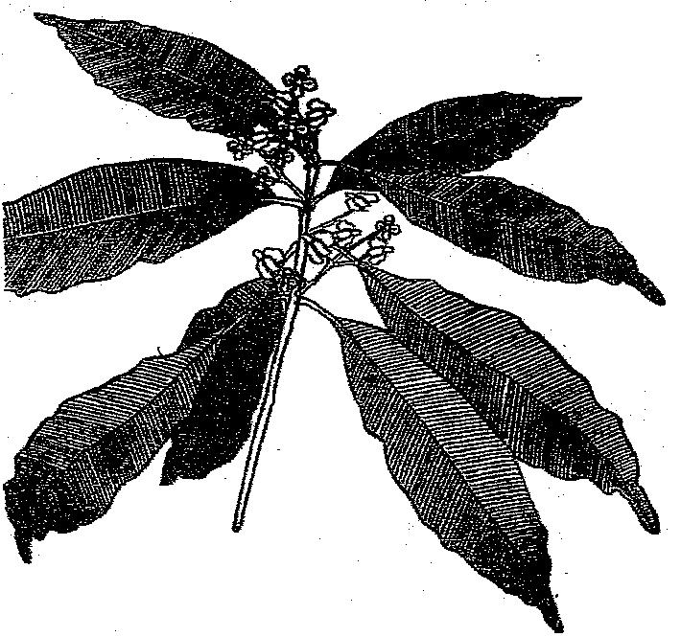 | 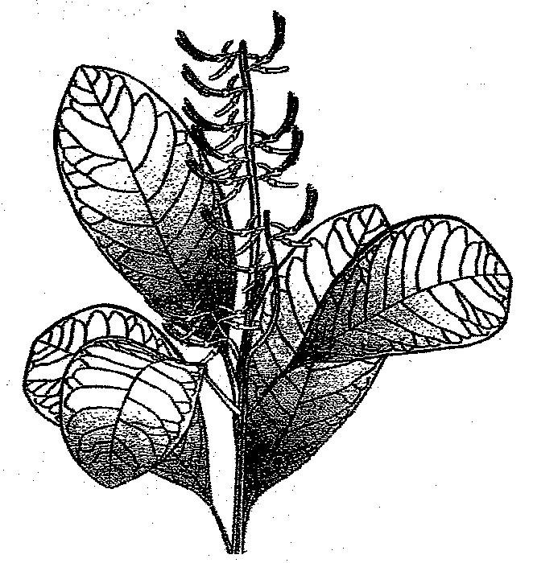
Lemonwood (Calophyllum brasiliense) | White Mahogany (Vochysia guatemalensis)
3) Management Practices for Timber and Cocoa Trees.*
Enriched Forests have Younger Trees, Trees In Production, and Older Trees.
Management of Younger Trees. During the early years of enrichment, a 1m area around each Timber and Cocoa Tree should remain clean without competition from other plants. Also, annual formation pruning should be realized in the upper parts of the Cocoa Trees forming multi-trunked shrubs which increases commercial production. Also, annual formation pruning should be realized on the lower branches and multiple stems of the Timber Trees forming tall single-trunked trees which increases timber production. The best time to prune Timber and Cocoa Trees is during the major annual dry period which reduces infection and favors healing.
Management of Trees in Production. With Timber and Cocoa Trees in production, annual sanitary pruning of supernumerary, diseased, and dead branches improves commercial production. Also, rejuvenation pruning of less productive adult Cocoa Trees stimulates and improves commercial production. Rejuvenation pruning should be done after the major annual Cocoa harvest by cutting about 1/3 of the less productive branches. The best time to prune Timber and Cocoa Trees is during each major annual dry period which reduces infection and favors healing.
Renovation of Older Trees. To sustain the production of Timber and Cocoa in large enriched forests, FIRST during each annual dry period, one should selectively remove the older unproductive Timber and Cocoa Trees, as well as selectively remove other competing non-useful trees. SECOND, during each annual wet period, one should replant the Timber (10m x 10m) and Cocoa (5m x 5m) Trees using local native Timber Tree seedlings from natural regeneration and seeds from the more productive local Cocoa Trees.
___________________
*Enríquez, G. (1987) Manual del Cacao para Agricultores. Coedición CATIE-ACRI-UNED,
Editorial Universidad Estatal a Distancia, San José, Costa Rica.

Agro Ethno ecology

Our Life Support System
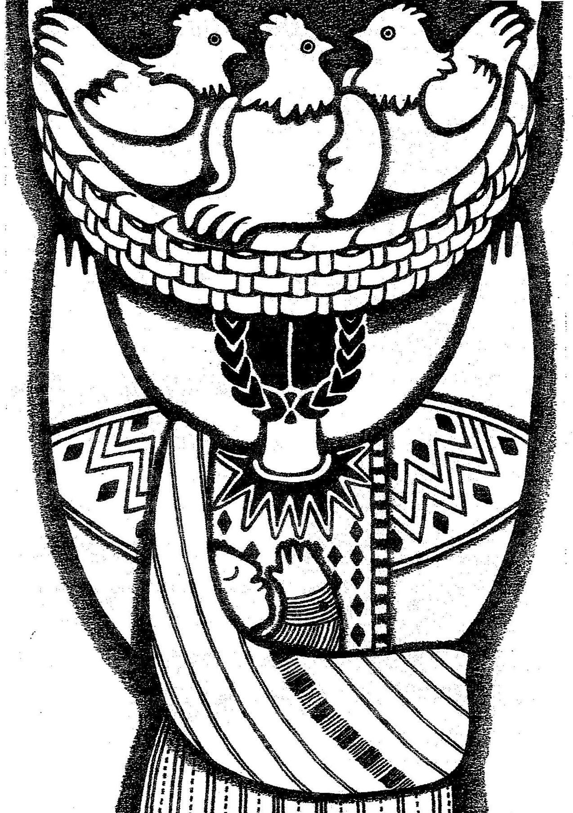
“…Be faithful in small things…” Matthew 25:23(b)

Agro Ethno ecology

Our Life Support System

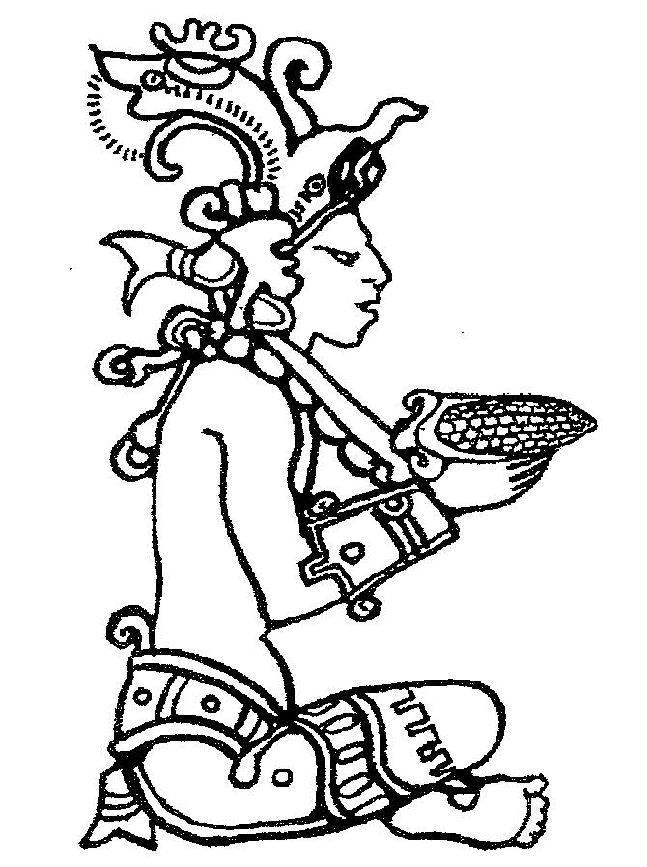

YUM KAX

Discoverer of Corn

Founder of American Agriculture

Mayan Culture 2500 B. C.

